UN Security Council - Responding to the Crisis in Haiti

The Crisis in Haiti

The Caribbean country of Haiti is experiencing unprecedented crisis in light of the assassination of President Jovenal Moises last summer, natural disasters during the just completed Atlantic Hurricane season and the consolidation of gang rule over the Haitian capital Port Au Prince. These developments have undermined an already precarious economy, precipitating the exodus of the desperate migrants. The United States is the major power that is closest and which has influenced the course of Haiti’s political and economic development. But the current Biden administration has little appetite for engaging in another U.S. military operation to stabilize Haiti. Indeed, Biden summarily deported Haitian migrants attempting to enter the United States in order to claim refugee status, prompting the resignation of U.S. Special Envoy to Haiti, Daniel Foote in September of 2021.

Back in Haiti, gangs have the paralyzed Port Au Prince by engaging in kidnapping, extortion and imposing fuel blockades. On this last point, the UN warned in late October that lives were likely to be lost in Haiti because of the impact of fuel blockades on the hospitals. Under these conditions, it is well-nigh impossible for Haiti's caretaker government, led by Ariel Henry, to restore social, economic and political order. The problem of gang violence is not new to Haiti. Haitian leaders have used gangs to consolidate political power and silence their opponents. This would include the slain president Jovenal Moises that used gangs to suppress civil society resistance and protest to his rule. It would include long-time dictator Papa Doc Duvalier, linked some 60,000 extrajudicial during the 1960s. Even the democratically elected Jean Claude Ariside used gangs in order to secure his government from being overthrown during his tenures (1991-94 and 2001-4) as president of Haiti.

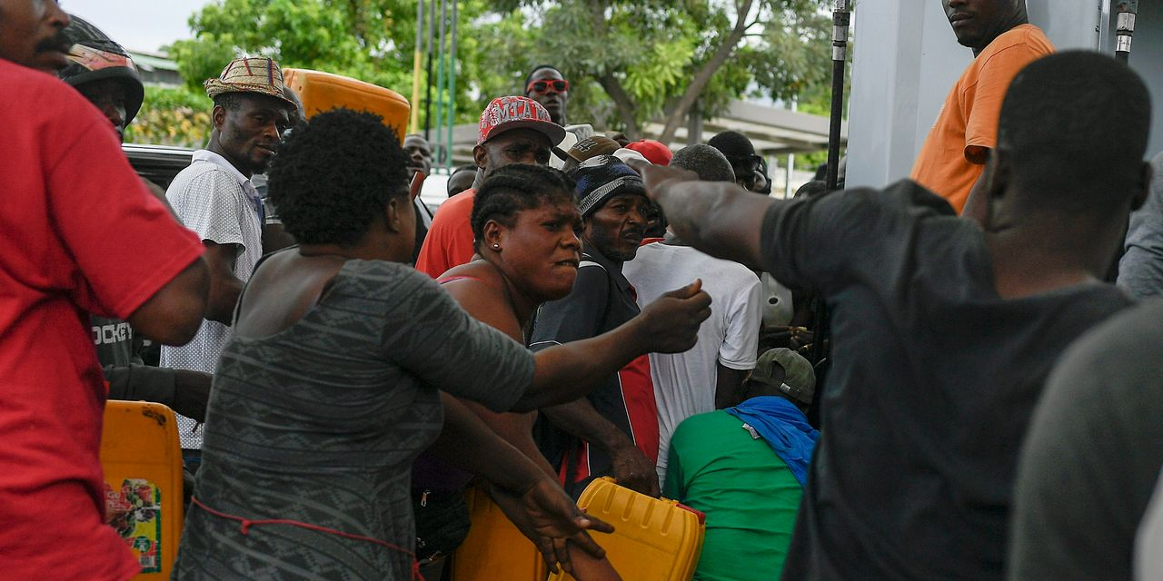
Wall Street Journal: Haiti on the brink of anarchy amidst hunger, violence and power vacuum.

Bringing Back the UN?

Indeed, the one corrective to gang rule in Haiti has been UN intervention. From 2004 to 2017, the UN deployed a peacekeeping force in Haiti, MINUSTAH. The mission was mired in controversy because of episodes of sexual violence that occurred between the Peacekeepers and Haitian women and on account of the transmission of a deadly cholera epidemic from peacekeepers to Haitians. But, argues a recent post from the Brookings Institute, these negative events should not detract attention away from the accomplishments of the MINUSTAH. These are particularly important to take note of in light of the fact that the United States will not act unilaterally and that leaving Haiti to its own devices is only likely to prolong its political, economic and humanitarian crisis. MINUSTAH, in fact, succeeded in dislodging gang power in Port Au Prince, as Brookings suggests:

A U.S. Institute of Peace study attributed the “resounding success” of these operations to the effort by the Brazilian military forces, working with various U.N. police units, to use the force necessary to clear neighborhoods of gang leaders. Brazilian troops conducted foot patrols, engaged with community leaders and members on the street, and developed extensive intelligence networks that were unprecedented at the time for U.N. peacekeeping. In a 2007 poll, 67% of respondents in Haiti credited the U.N. with improved security.

Additionally, Brookings recommends giving international civilians more power to replace corrupt officials in the process of rebuilding Haiti’s police and security forces. Too often in the past, security and assistance programs have left corrupt officials in place. This is a point that applies not only to Haiti but numerous other developing countries that are the recipients of security assistance from the U.S. or from other developed countries (on this point, see Stuart Shrader’s essay, Defunding the Global Policeman). The recent experiences of Honduras and Guatemala provide useful precedents for how investigations and prosecutions for the corrupt official behavior might unfold under the auspices of the renewed UN mission to Haiti. A recent paper highlights some of the success of these missions.

The Role of Haitian Civil Society

Monique Clessca, one of 13 commissioners that form the leadership of a prominent civil society group in Haiti, Commission for a Haitian Solution to the Crisis, proposed in the New York Times the appointment of an interim government by various civil society organizations that can lay claim to representing the interests of different sectors of the Haitian population and diaspora. The proposal formulated by Clessca’s group did not meet with governmental approval.

Mr. Henry, the unelected, de facto prime minister, quickly proposed a rival plan that would consolidate all power of the interim government in his hands. It focuses on quick elections without sufficient reform to make them credible or ensure wide participation. And most of its supporters represent groups that are already aligned with and benefiting from the existing corrupt, predatory and failing system.

Contrary to Brookings, Clessca is suggesting that the crisis in Haiti does not need a new international intervention, although it does require substantial political and economic support from the international community.

Paul Angelo of the Council on Foreign Relations suggests a limited UN military footprint in Haiti, designed to facilitate the delivery of fuel and humanitarian supplies and gearing up an anti-impunity and corruption mission similar to what was mounted in Guatemala. Angelo anticipates, though, that China might veto Security Council action on this matter and so he advocates that the Organization of American States be prepared to carry out election oversight and refugee resettlement in order to stabilize Haiti. Ultimately, Angelo concludes, the solutions to Haiti’s problems depend on Haiti’s authorities. But this is also the historical crux of the problem and why civil society activists like Clesca would advocate enabling Haitian civil society to transform the dysfunctional Hatiian state.

The charge of the Security Council is straightforward. How to formulate an UN response to the chaos that has gripped Haiti. Among the considerations that delegates should bear in mind are the following:

Guiding Questions

- What are the lessons of the previous UN Mission to Haiti, MINUSTAH. How can the shortcomings of that mission - sexual violence and disease transmission - be avoided? How can its efficacy in tamping down gang violence be repeated?
- Should there be an international armed intervention in Haiti and, if so, with what weapons and with what rules of engagement?
- What is the general importance of Haitian civil society to the problem of reconstructing the Haitian government so that it can provide basic security for all Haitians? Is trying to get the existing government simply to reform itself a dead end?
- If there is a new mission to Haiti, then how will that mission operate in relation to the Haitian government and in relation to Haitian civil society?
- What would be the possible usefulness of anti-corruption and impunity campaigns in Haiti similar to those that have been waged in Guatemala and Honduras?
- What role should governments play in resettlement of Haitians uprooted by the crisis in Haiti. Is there a formula for burden sharing among states in the region for refugee resettlement?

Further Reading

- Charles T. Call, “Haiti needs a new, improved UN Mission,” Brookings Institute, December 2, 2021.
- Paul Angelo, “There’s a new kidnapping capital of the world. Here is what to do about it.” New York Times, October 25, 2021.
- Stuart Shrader, “Defund the Global Policeman,” N+1, Fall 2020.
- Monique Cresca, “My group can save Haiti. Biden is standing in our way” New York Times, December 1, 2021.
- Haiti reading list, North American Congress on Latin America: Report on the Americas
  - After Moïse Assassination, Popular Sectors Must Lead the WayMamyrah Dougé-Prosper and Mark Schuller | July 8, 2021
Analysis the day after the Haitian president's assassination focused on liberal constitutionalism and elections. This narrow view overlooks the longstanding demands from organized popular sectors. Read more.
- The Foreign Roots of Haiti’s “Constitutional Crisis” Mark Schuller | February 6, 2021 Haiti’s president’s term has come to an end, but he refuses to step down. Solidarity is urgent. Read more.
- The Political Anatomy of Haiti’s Armed Gangs
Djems Olivier | Spring 2021 NACLA Report
In Port-au-Prince, botched NGO and military inventions have fragmented urban space, triggering an explosive proliferation of violent armed groups. Read more
Trapped in the Imperial Grip
James Darbouze | Spring 2021 NACLA Report
The United States’ systemic anti-Blackness at home and abroad shatters illusions of democracy in Haiti. Achieving true independence demands solidarity. Read more.

Professor Charles Call provides an overview of these experiences: - As the UN Mission in Guatemala (MINUGUA) was preparing to leave eight years after the 1996 peace agreement, human rights organizations there became concerned about an uptick in killings of justice officials and NGO activists. They worked with UN officials and sympathetic government officials to propose a new UN mission that would fight shadowy illegal armed groups and have the power of independent prosecution. However, that proposal was rejected by the courts and resisted politically. A couple years later, government officials who were worried about these unaccountable and corrupt armed groups introduced a modified version that was approved as CICIG in December 2006. - In the case of Honduras, the news of USD$300 million stolen in a large corruption scheme from the Honduran Social Security Institute (IHSS) caused popular outrage in 2014.4 The following summer, just as CICIG’s investigation was bringing down the president of Guatemala, Honduran president Juan Orlando Hernández – hounded by allegations – admitted his campaign had benefitted from the stolen IHSS money.5 Throughout mid-2015, tens of thousands marched in the streets of the country’s main cities every Friday demanding Hernandez’ resignation and the creation of a Honduran equivalent of CICIG.6 Both cases show how nongovernmental actors were vital. However, Hernández was able to save his presidency with a mission whose weaker terms of reference blunted its ability to strike decisive blows against the most corrupt structures in the country.

