The United States has finally ended its 20 year war with Afghanistan, the war cost trillions of dollars in addition to the lives of more than 2,000 U.S. service members and at least 100,000 Afghan civilians who were injured or killed. The Pentagon said previously that there were 8,400 troops in Afghanistan, but the actual "total force" number was closer to 11,000. Afghans face the confluence of multiple crises just as President Biden withdraws American forces. A resurgent of the Taliban movement now controls or contests more of the country’s territory than at any time since 2001. With the country on the brink of economic collapse, the world waits to see how the Taliban plans on ruling with no aid from the U.S., its NATO allies and international financial institutions such as the World Bank and the International Monetary Fund.
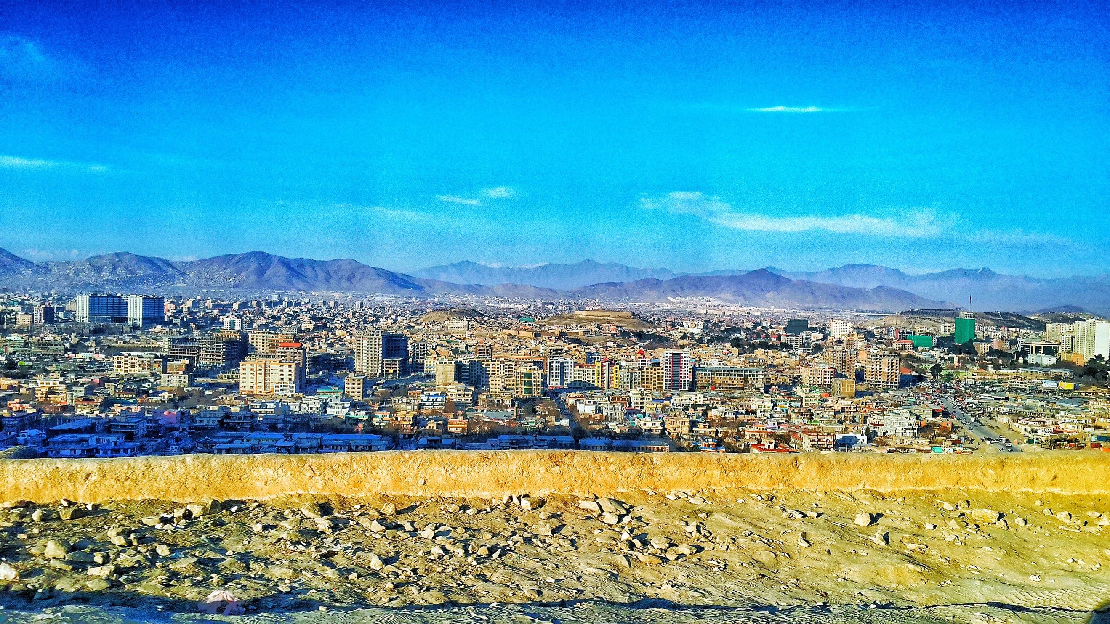
the future of Afghanistan
Nadjuska Maurice, Florida Gulf Coast University

This onset of Taliban resurgence has caused a major migration crisis with about 65 thousand people fleeing the country. There are some five thousand Afghan refugees in Serbia, fifty thousand in the United States, twenty-five thousand are being housed in military installations and thirty thousand more are displace in countries around Europe and the Middle East. The United Nations High Commission (UNHCR) has called upon neighboring countries to keep their borders open to those fleeing Afghanistan. “The UNHCR spokesperson commended Pakistan for having hosted Afghan refugees for decades, with 1.4 million registered there. He added that whilst he was aware of the pressures this poses, UNHCR remained ready to help national authorities to scale up the response to humanitarian needs.” The United Nations is trying to provide as much assistant as possible to these refugees. They have been assisting any displaced Afghans with life-saving shelter, food, water, and relief items to both those living in Afghanistan and those who have immigrated to neighboring countries.

State of insecurity
Security in Afghanistan has been threatened since 2001 when the United State invaded the country in the search of Al Qaeda terrorist. The US believed that Osama Bin Laden who was suspected of being behind the nine eleven terror attacks was hiding in Afghanistan under the Taliban’s rule. In October 2001 the United States supported by the British begins bombing Afghanistan, targeting Bin laden’s fighters and the Taliban. Since the first bombs dropped the U.S. continued its attacks on Afghanistan using airstrikes which often results in massive civilian casualties. In 2017 the U.S. military relaxed its rules of engagement for airstrikes in Afghanistan, as a result civilian casualties due to airstrike increase dramatically from 2017 to 2019, more civilians were killed in airstrikes in 2019 than at any time since 2002. The U.S., its allies, and the Afghan government also referred to as the pro-government forces (PGF) by the United Nations killed 582 civilians a year in the period between 2007 and 2016, but between 2017 and the 2019, that number increased by 95% to the 1,134 civilians per year, according to Brown University’s Cost of War Project. The number of civilians killed by international airstrikes increased about 330 percent from 2016, the last full year of the Obama Administration.” These airstrikes have created distaste for westerners for many Afghan civilians and has completely destabilized safety and security in Afghanistan. Civilians felt unsafe in their own homes fearing that the next airstrike will be the one that hits them.
Promises won’t feed people
After the fall of Kabul, the United Nations has restated that they intend to stay in Afghanistan and deliver aid to the millions of people in need. The combined impacts of droughts, conflict, COVID-19, and the economic crisis, have severely affected lives, livelihoods, and people’s access to food. The UN refugee Agency has advised a non-return advisory for Afghanistan calling for a bar on forced returns of Afghan nationals, including asylum seekers who have had their claims rejected. The Food and Agriculture Organization Director General states “It is urgent that we act efficiently and effectively to speed up and scale up our delivery in Afghanistan before winter cuts off a large part of the country, with millions of people – including farmers, women, young children and the elderly – going hungry in the freezing winter.” There are about 3.2 million children under five expected to suffer from malnutrition in Afghanistan. Hunger is rising and children are dying, there has been a 37 percent surge in the number of Afghans facing acute hunger since its last assessment in April. This has been a problem before the Taliban’s takeover with Some 665,000 people who were internally displaced because of conflict between January and September.

The 1951 Refugee Convention states that a refugee is “a person who is unable or unwilling to return to their country of origin because of a well-founded fear of being persecuted based on race, religion, nationality, membership in a particular social group, or political opinion. Persecution based on gender, including gender discrimination and persecution based on lesbian, gay, bisexual, and transgender (LGBT) identity, can also form the basis for refugee status. The threat of being tortured or of inhuman or degrading treatment provides grounds for nonrefoulement (non-return) under international human rights law.” In the days since the Taliban took over Afghanistan the United States led a multinational airlift assist to help many international passport holders and Afghans to flee on hundreds of evacuation flights from Kabul’s international airport. Officials reported about 125,000 people were evacuate in these airlifts. “Among Afghans who were evacuated with their families were those who had been granted visas linked to their service alongside coalition military forces or who had worked with foreign-funded programs. A smaller number of the Afghans seeking visas or asylum based on their fear of persecution due to their identity were also able to board planes as refugees, as were those with family members living as citizens abroad on the basis of family reunification” The Taliban authorities have been quoted saying they do not want Afghans to leave the country but that is a violation of the international rights law which ensures that everyone has the right to leave their own country. It is agreed that no one should be forcibly returned to Afghanistan at this time, thus there are now some hundreds of thousands of refugees seeking asylum.

Assisting Neighboring Countries

As of July, Iran hosted 800,000 registered refugees and up to 3 million other displaced Afghans. Refugees face abuse in Iran including being prohibited from living in “no-go areas,” being denied access to education, and being detained and deported without due process, Iran has pushed out almost 1.5 million Afghans back to Afghanistan. Iran also has regulations that restrict Afghan refugees’ rights to obtain mortgages, to rent and own property and open bank accounts. Those who do find lawful employment can expect to face unfair treatment and discrimination in the workplace. Iran with the assistance of the UNHCR has deported approximately 902,000 Afghan refugee’s residing in Iran. “In 2012, UNHCR assisted the departures of 1,427 Afghan refugees from Iran, three times the 2011 figure of 474 refugees.”

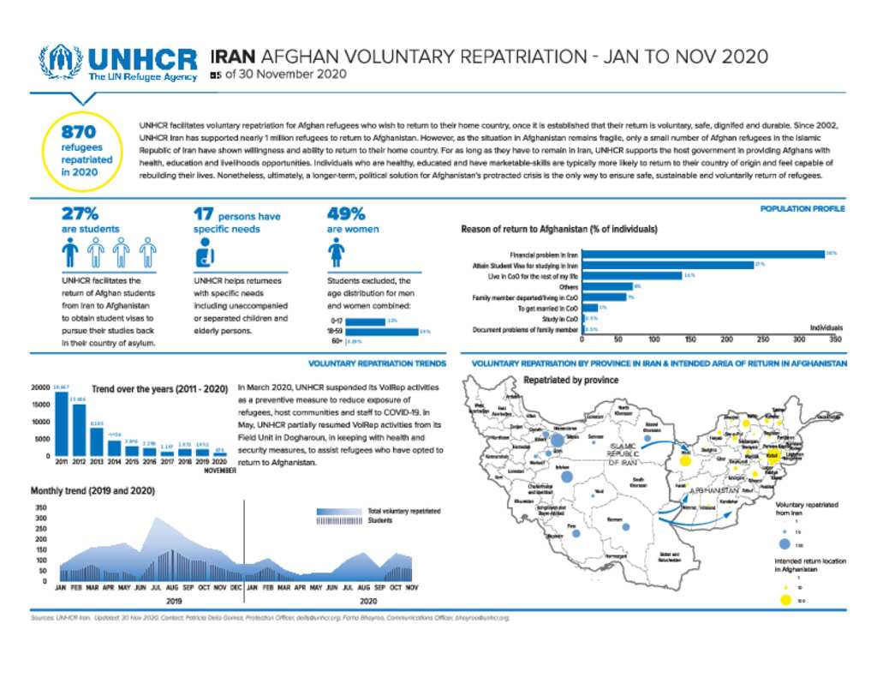

Pakistan has 1.4 million registered Afghan refugees and up to two million displaced Afghans, they hold no official status and cannot legally work. Pakistan is not a signatory to the 1951 Refugee Convention and thus has no national refugee legislation. In 1995 the food aid from the UNHCR and the World Food Programme meant to support Afghan refugees in Pakistan were suspended and international aid was decreased. Afghan refugees in Pakistan instead receive a proof of registration (POR) card that entitles them to freedom of movement and temporary legal status. POR card holders cannot access formal education, work in the formal sector, buy property, or even access public healthcare. By 2011 fear of terrorism from refugee camps spread fear to the Pakistani community. A 2016 poll found that 90 percent of Pakistanis supported blocking Afghans without visas from entering the country in an effort to reduce terrorism in the country. In 2015 the Pakistani government was looking for ways to increase the number of refugees voluntarily returning to Afghanistan, they offered each family 400 dollars to return, from 2002 to 2012, the UNHCR facilitated the largest voluntary repatriation programme which 3.8 million refugees returned from Pakistan to Afghanistan. This scaled down throughout the years due to the insecurity in Afghanistan.

Voluntary repatriation of Afghan refugees from Pakistan since 2002
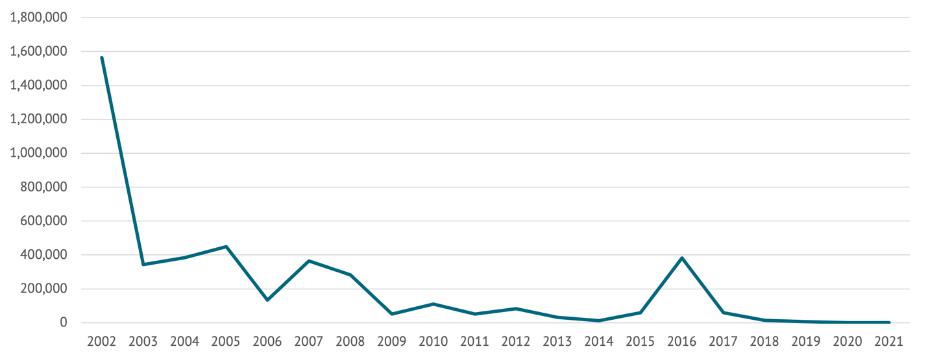

Aid/Policy Conditions Conundrum

One way of facilitating repatriation of the Afghan refugees from Iran and Pakistan to Afghanistan would be to improve living conditions there. But Afghanistan is now teetering on the brink of the humanitarian catastrophe with much of its international aid flows and external assets either suspended or frozen. The United States and its allies have been seeking a kind of quid pro quo from the Taliban: relaxation of sanctions and unfreezing of the foreign funds in exchange for the domestic policy concessions, such as permitting Afghan girls to the attend school and allowing the unimpeded flow of humanitarian aid into Afghanistan. The U.S., which has currently frozen the $9 billion in Afghan assets, also prioritizes counter-terrorism policy in Afghanistan as a core U.S. national interest. The New York Times reported in the November of 2021 that “…the United States was in no rush to unfreeze the Afghan assets, or to provide diplomatic recognition — reiterating the U.S. position that the Taliban must show they are governing inclusively, protecting human rights, preventing terrorist activity and ensuring freedom of movement from the country.” Economist Marc Weisbrot notes that the $9 billion represents about 18 months of the imports that Afghanistan requires and he adds that “[t]here's nothing legal or legitimate about this. Imagine you had a bank account and the bank just decided to take your money. That is what they're doing. There's no legal excuse for that.” The but U.S. worries that if the Taliban does get access to these funds, there is no reason to believe that they will spend it well or fairly. Is this, perhaps, a neocolonial attitude on the part of the United States? At what point does the use of aid as a leverage for domestic policy reform become an attack on the very notion of human rights that the U.S. says it is committed to defending?

It is clear that the EU is taking a different course. The EU recently pledged $1.15 billion in aid to Afghanistan and surrounding countries. New York Times: “We must do all we can to avert a major humanitarian and socio-economic collapse in Afghanistan,” Ursula von der Leyen, the president of the European Commission, said in a statement. “We need to do it fast.” Surely Europe still recalls how the civil war in Syria led to the mass exodus of refugees from the region into surrounding countries as well as Europe. At stake here was the control of violence. Failure to control violence leads to waves of instability that radiate outward, affecting not only the region, but adjacent regions. The rise of the political right in Europe can be tied to the civil war in Syria and its consequences. In the case of Afghanistan, what is at stake is not so much the control of violence but the control of suffering. Unabated suffering will generate the same outward radiating waves of political, economic, and social instability. Worse, of course, is the suffering itself. The economy and social services of all kinds (health and education) are grinding to a halt because Afghanistan lacks access to money and needed imports. This is a government which, before the victory of the Taliban last summer, depended on foreign aid and grants for 75% of budget. Aside, perhaps, the illegal exports of poppy and heroin, the Afghan economy as whole has been devastated by four decades of more or less continuous warfare. Pulling the plug on most aid flows risks a humanitarian catastrophe. One, in fact, is reminded of the United States imposing harsh sanctions on Iraq during the 1990s, which resulted in the deaths of over 500,000 children in Iraq because the government lacked the ability to import needed food and medicine. On the CBS News Progress 60 Minutes in journalist Leslie Stahl noted that “We have hear that a half a million children have died. I mean, that more children then died in Hiroshima. And, you know, is it worth it?” Secretary of State Madeline Albright duly replied: “I think this is a very hard choice, but the price – we think the price is worth it. One might pose a similar question about Afghanistan today.

What can be done?

The UN remains committed to assisting Afghan refugees, the UNHCR is urging refugee host countries governments to prioritize reuniting Afghan refugees and their families. Reuniting these families ensures preservation of family unity, this is a principle protected under international law, it can also help to protect lives based on the exceptionally challenging situation in Afghanistan. UN Secretary-General António Guterres’ states in a council meeting that the United Nations continues to have staff and offices in areas that have come under Taliban control. The Secretary General emphasizes the importance of basic services reopening; he states that it is crucial for civil servants’ salaries to continue to be paid, infrastructure to be maintained, airports to reopen and health and education services continue.

Guiding questions-

- Consider the violence and insecurity occurring in Afghanistan, what policies and actions have created this refugee crisis?

- What can be done by the UN to further assist those remaining in Afghanistan after the Taliban took over? Areas to consider here would be not only the delivery of emergency supplies but also use of aid flows to the pay the salaries of public employees and avoid a process of state collapse in Afghanistan.

- What kinds of conditions – if any – should be placed on the restoration of aid flows to the government of Afghanistan, which is now controlled by the Taliban? There are many conditions one might think of: the status of girls and women, counter-terrorism, UN or international control over aid flows (to ensure they reach their intended targets), counter-narcotics policy, treatment of the Americans and members of the international community that remain in Afghanistan.

- What can be done to facilitate ability of the Afghans to remain in Pakistan and Iran until they can be repatriated back to Afghanistan? What can be done to ensure the security of countries that host refugee communities which include members of terrorist groups? This have been an enormous problem in Pakistan. What can be done to enable refugees to find employment, and gain access to essential goods and services?

- Finally, it is worth considering the longer-term future. Afghanistan is endowed with significant natural resources. The website, The Conversation, notes that “Afghanistan possesses a wealth of nonfuel minerals whose value has been estimated at more than US$1 trillion. For millennia the country was renowned for its gemstones – rubies, emeralds, tourmalines and lapis lazuli. These minerals continue to be locally extracted, both legally and illegally, in mostly small, artisanal mines. Far more value, however, lies with the country’s endowments of iron, copper, lithium, rare earth elements, cobalt, bauxite, mercury, uranium and chromium.” What kinds of connections can be drawn between the development of these resources and the immediate objective of averting state failure and humanitarian catastrophe in Afghanistan?

References

United Nations. (n.d.). “Afghanistan: Reuniting families on the run should be priority, urges UNHCR | | UN News.” United Nations. Retrieved December 12, 2021, from https://news.un.org/en/story/2021/10/1103182
Crawford, N. C. (2020, December 7). “Rising civilian death toll in Afghanistan costs of war.” Watson institute. Retrieved December 12, 2021, from https://watson.brown.edu/costsofwar/files/cow/imce/papers/2020/Rising%20Civilian%20Death%20Toll%20in%20Afghanistan_Costs%20of%20War_Dec%207%202020.pdf
Subscribe. “Share .” “Afghan Refugees in Iran & Pakistan | European Resettlement Network,” ICMC Europe, 2013, https://www.resettlement.eu/page/afghan-refugees-iran-pakistan-0
2021, September 28). “What's Next for Afghans Fleeing the Taliban?” (Retrieved October 7, 2021, from https://www.hrw.org/news/2021/09/09/whats-next-afghans-fleeing-taliban
United Nations. (2021, December 25) “Afghanistan on “countdown to catastrophe” without urgent humanitarian relief.” Retrieved November 12, 2020, https://news.un.org/en/story/2021/10/1103932
United Nations. (2021, August 16) “We cannot, must not abandon people of Afghanistan, secretary general tells security council meeting, stressing ‘the world is watching’”. Retrived December 5, 2020 https://www.un.org/press/en/2021/sgsm20853.doc.htm
Amparado, Danielle. Dempster, Helen. Laghari Imran. (25, August 2021) “With US withdrawal, Rights of afghan refugees in Pakistan hang in the balance.” Retrieved December 5 2021 https://www.cgdev.org/blog/us-withdrawal-rights-afghan-refugees-pakistan-hang-balance
Witte, Melissa De. (19, July 2021) “The US withdrawal from Afghanistan has encouraged the Taliban to stake their future on the battlefield, Stanford scholar says.” Retrieved December 5 2021 https://news.stanford.edu/2021/07/19/whats-next-afghanistan/
Shesgreen, Deirdre. (2, July 2021) “US troops leave Bagram airfield, suggesting full US withdrawal from Afghanistan is near.” Retrieved December 5 2020 https://www.usatoday.com/story/news/politics/2021/07/02/us-military-vacates-bagram-airfield-full-afghanistan-withdrawal-near/7832148002/
The US war in Afghanistan timeline
https://www.cfr.org/timeline/us-war-afghanistan
what’s next for Afghans fleeing the Taliban
https://www.hrw.org/news/2021/09/09/whats-next-afghans-fleeing-taliban#Q4

A great source to read to understand the UN response is “UN commits to staying in Afghanistan, with basic services close to collapse.” (2021)
For an informational article that explains the intensity of the situation is Crawford, Neta “Afghanistan’s rising civilian death toll due to airstrikes 2017-2020” December 2020 https://watson.brown.edu/costsofwar/files/cow/imce/papers/2020/Rising%20Civilian%20Death%20Toll%20in%20Afghanistan_Costs%20of%20War_Dec%207%202020.pdf
A relevant and key document to review in order to fully understand the crisis in Afghanistan is “Afghanistan on ‘countdown to catastrophe’ without urgent humanitarian relief” (2021) https://news.un.org/en/story/2021/10/1103932
A great resource that can be used to further understand the Taliban’s rule is “what’s next for Afghans fleeing the Taliban” (2021) https://www.hrw.org/news/2021/09/09/whats-next-afghans-fleeing-taliban
To learn more about Afghan refugees in Iran refer to “Afghan refugees in Iran and Pakistan” https://www.resettlement.eu/page/afghan-refugees-iran-pakistan-0
Graphic from “Iran Afghan voluntary repatriation” https://reliefweb.int/report/iran-islamic-republic/iran-afghan-voluntary-repatriation-oct-2021-31-october-2021
Further research about refugee workers’ rights in Pakistan can be found In this article https://refugeeworkrights.org/scorecard/pakistan/

