Vaccinating the Global South

By Madison Alberts

COVID in the Global South

As COVID-19 restrictions are coming to a close and vaccinations are skyrocketing in high-income countries in the Northern Hemisphere, the Global South is becoming tormented with another wave of the virus in addition to vaccine nationalism. At the time of writing, 46% of citizens in the United States, 52% of citizens in the United Kingdom, and 63% of citizens in Israel have been vaccinated (Mathieu et al. 2021). However, there is a different story unfolding in the Global South: the entire continent of Africa has a vaccinated population just breaking over the one percent mark. Likewise in Southeast and Central Asia, the vaccinated population varies between zero and eleven percent with Cambodia having the most people vaccinated (excluding Bhutan whose population is 62% vaccinated). The only continent in the Southern Hemisphere to begin to grow its vaccinated population numbers is South America, where Chile and Uruguay are averaging around 45% and 35% respectively.
Why is there such a grand divide between those in the Northern and Southern Hemispheres? There are a few key players to consider: international organizations (both governmental and non-governmental), the states themselves, and the private companies who develop and research the vaccines. Simply put, there are about four international organizations that are running the show: Covax, the World Health Organization (WHO), the Global Vaccine Alliance, and the World Bank (Felter 2021). Furthermore, the key private development companies are Johnson & Johnson (J&J), Phizer and BioNTech, and AstraZeneca (Felter 2021). These companies sell contracts to individual countries and international organizations in which the highest paying buyer gets the product. In other words, think of an auction where the country/organization who pays the most money or secures the contract(s) first, gets the vaccine. The issue lies in the fact that many low-income countries cannot compete in a system like this; that is where organizations like Covax and the WHO come into play. They are trying to even out the playing field in order to stop the continuity of the virus for the world, not half of it.
According to the Director-General of the WHO, Tedros Adhanom Ghebreyesus, “only 0.3% of the vaccines administered around the world so far had gone to people in low-income countries” (BBC News 2021). Now, Covax and the WHO are in a vaccine and financial deficit. The organizations need approximately $35-45 billion USD and 20 million doses of vaccinations for most adults worldwide by the end of the year to stay on track (BBC News 2021). States are encouraged to donate supplies and research, but many are hesitant to do so. From their perspective, it is a dog-eat-dog world, and they must prioritize their own country’s safety first before worrying about another. Thus, vaccine nationalism is the exact fear that many international organizations like Covax and the WHO have, because it means while high-income countries slowly return to normal, more people from less wealthy nations will die in the meantime. It also undermines the concept of a united, international response to a global pandemic. The question that must be answered is how can these three players cooperate to make an effective and efficient response to the COVID-19 pandemic?

Background Information:
Looking back throughout history there are plenty of different examples of pandemics to examine; one such example is HIV/AIDS. The HIV/AIDS pandemic is believed to originate from the Democratic Republic of the Congo (DRC) and had intermittent appearances before the 1970s. It was not until the late 1970s and early 1980s did the crisis kick into gear. By this time, the curve of infection and death rates were beginning to climb and peaked in the early 2000s. From there, there was a slightly slower decrease in such rates until it stagnated at approximately 750,000 deaths each year in the late 2010s. Before this all happened though, there was a growing sense of complacency within the public health industry (Fox, n.d.). When the starting stages of the pandemic began, there was a slow and poorly motivated response due to the groups of people most at risk: homosexuals (men in particular), hemophiliacs, heroin addicts, and Haitians. These groups were looked down upon by many societies for their “lifestyles” and addictions. In other words, not only was the response to the HIV/AIDS crisis lethargic because of the complacency being felt by the international public health community, it was also because the victims of this disease were mainly those of social pariah groups (i.e. homosexuals and drug addicts).
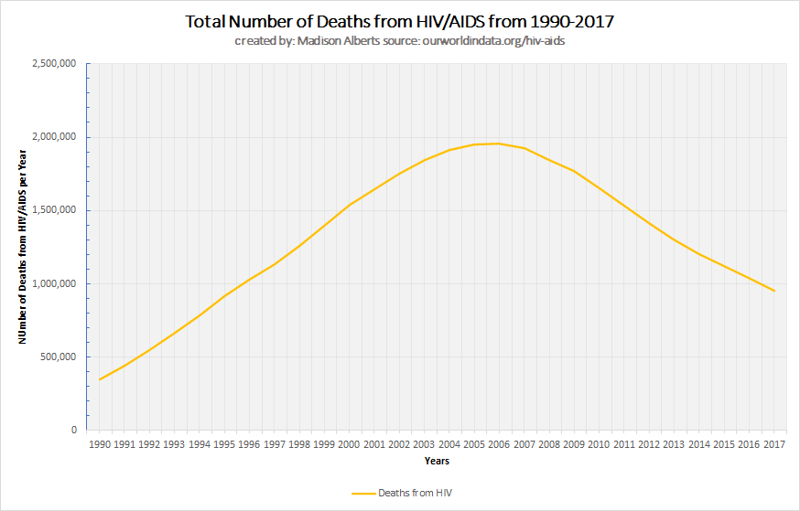
In addition to the victims of the “gay plague” being radically deprived of equal healthcare opportunities, another reason as for the crisis’ continuity was because of intellectual property rights. It took twenty years from the start of the HIV/AIDS pandemic in the early 1980s for a comprehensive and international waive on intellectual property rights regarding information on HIV/AIDS treatments. This declaration was created in 2001 and was recognized as the Doha Declaration on the TRIPs Agreement and Public Health (Wei 2006). Within this agreement, it states:
“… Where compulsory licenses are granted to address a national emergency or other circumstances of extreme urgency, certain requirements are waived in order to hasten the process, such as that for the need to have had prior negotiations obtain a voluntary license from the patent holder…” (World Health Organiztion n.d.).
The issue here is that other than these grounds, it gives the members of this agreement full responsibility and freedom to stipulate all other conditions. On the other hand, it is critical to keep in mind that even though this agreement allows the sharing of intellectual property rights which thus allows cheaper drugs to be developed and sold, the loss of this protection does not provide the security or incentive to produce these drugs (Wei 2006). Basically, without the agreement put in place, during health crises like HIV/AIDS with antiretroviral treatments (ART) and COVID-19 with the vaccines pharmaceutical companies can monopolize desperately needed medicine for high prices making it nearly impossibly for low-income citizens or countries to afford. Today, this phenomenon can be seen with vaccine nationalism.
Furthermore, it is important to know that the response to AIDS was fragmented by differences in international and national public health policy. It wasn’t until 1988 that the Office of the High Commissioner on Human Rights (OHCHR) and the United Nations AIDS (UNAIDS) programs created the International Guidelines on HIV/AIDS and Human Rights. Later, in 2009 comprehensive legislation was created in the US with the Ryan White CARES Act, which became a template for other nations worldwide. Other worldwide implications include the bilateral/multilateral sharing of information and knowledge, monetary aid to other nations, and technical development towards medical programs and infrastructure (Institute of Medicine (US) Committee on a National Strategy for AIDS 1986). A US strategic plan stated quite bluntly that:
“If the United States and other developed countries fail to vigorously support and, where appropriate, to become involved in efforts to control AIDS and HIV infection at all levels internationally, millions more than those now infected in poorer countries may die of this infection over the next decade or so...” (Institute of Medicine (US) Committee on a National Strategy for AIDS 1986).
Like the HIV/AIDS pandemic thirty years ago, little was known about the COVID-19 virus when it first began to spread last year. It was significantly different from previously known coronaviruses and was first discovered in Wuhan, China in December 2019 (Center for Disease Control 2020). Unlike other coronaviruses found in humans before, COVID-19 is a new, deadlier version of an upper-respiratory tract infection in which ailments include cough, fever or chills, shortness of breath or difficulty breathing, muscle or body aches, sore throat, new loss of taste or smell, diarrhea, headache, new fatigue, nausea or vomiting, and congestion or runny nose (Maragakis 2021). These and more life-threatening symptoms are similar to COVID-19’s coronavirus cousins SARS-CoV2 and MERS-CoV.
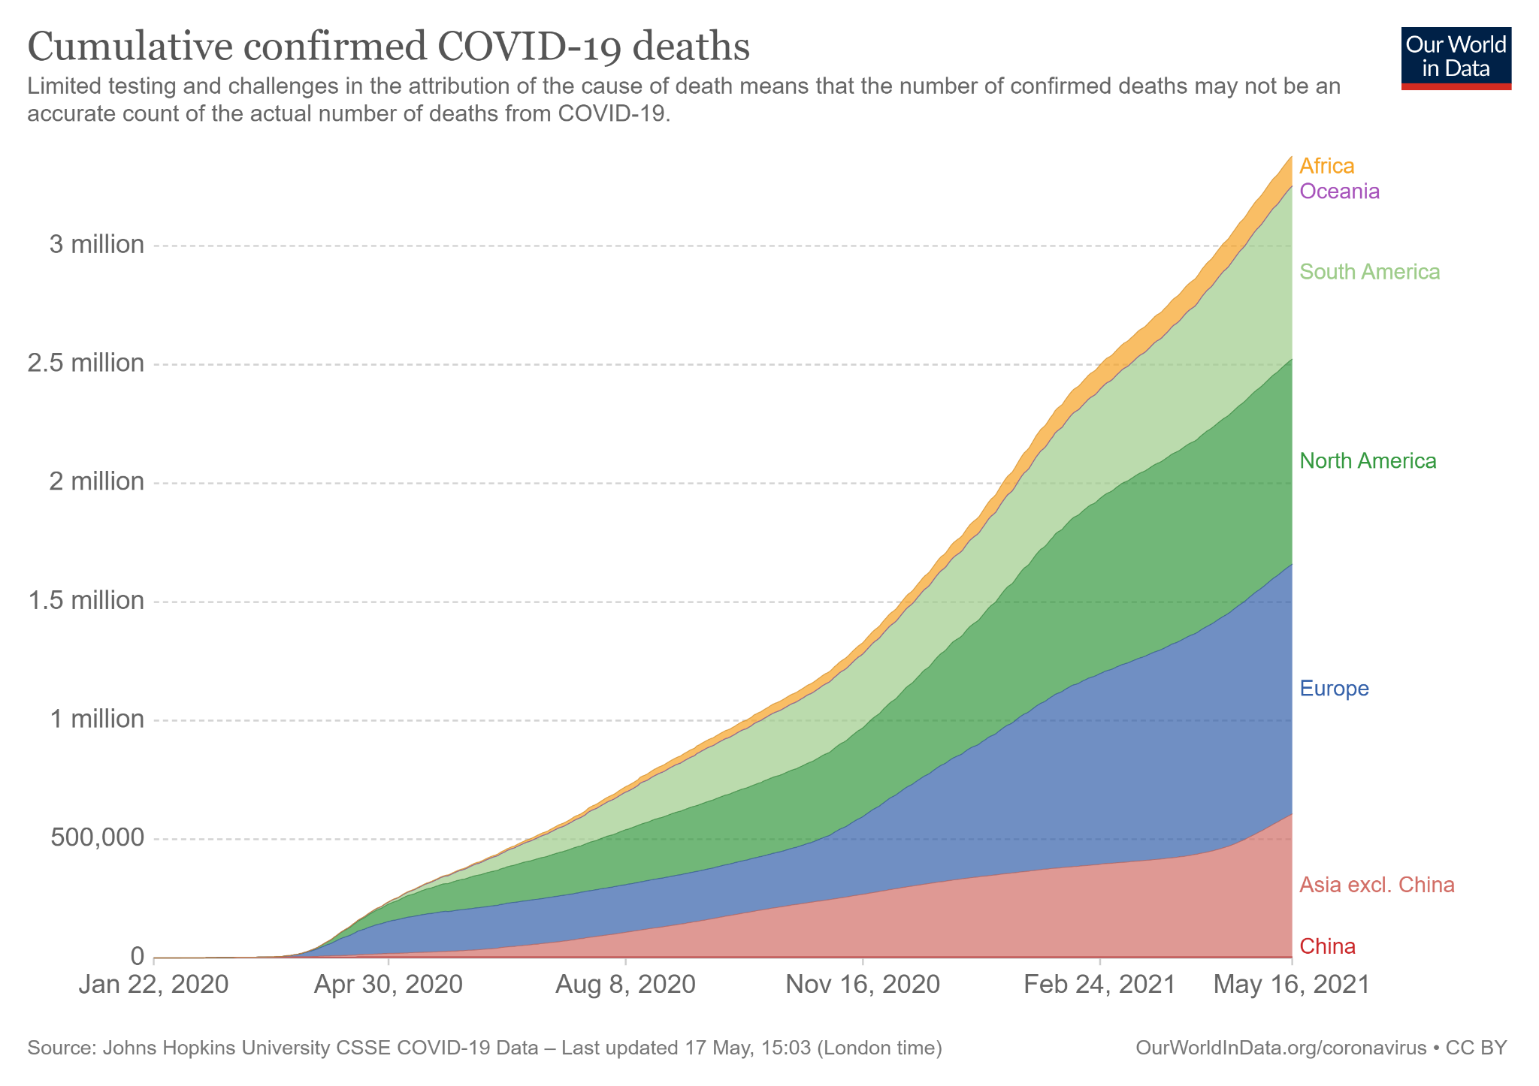
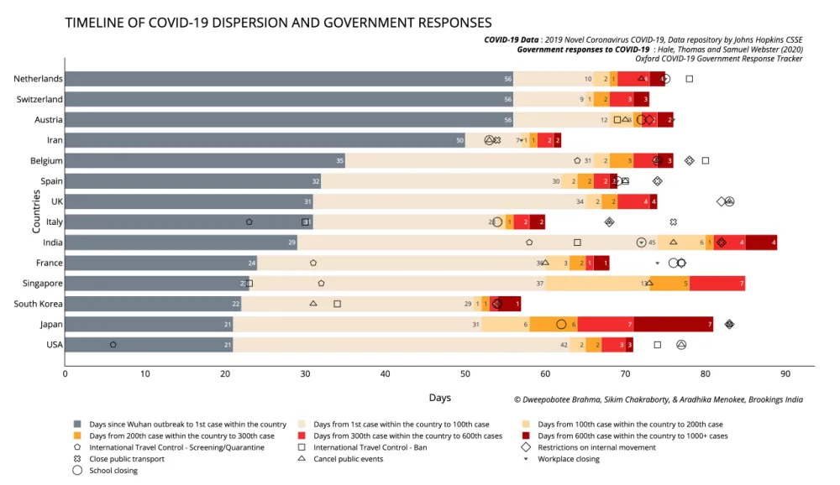
As very many know, COVID-19 has taken over almost every aspect of daily life, but for some, its savagery has taken more than day-to-day lifestyle changes. So far, over 3.4 million people have died due to the virus and over 162.8 million cases have been confirmed worldwide (Our World in Data 2021, World Health Organization 2021). Part of the reason as to why there have been so many cases worldwide is because there was a mixed, highly diverse, and for many, a slow response to the outbreak. The speed of the spread depended on a few key factors such as: “connectivity and proximity… cultural and behavioral responses of the community, population density, and average household size…” (Bhrama, Chakraborty, and Menokee 2020). It is interesting to note from the graph below that those countries who took the initiative early and prepared themselves for the pandemic were better off than their less-prepared counterparts (Bhrama, Chakraborty, and Menokee 2020).
Current Developments:
Over the course of the last several months, vaccine rollouts have been continuing in more developed nations, but there is an argument over “global public goods” (GPGs) and their relationship with the pandemic (Brown and Susskind 2020). Global public goods are goods that are open for public use without exclusivity and rivalry that are international in scale (Smith 2003, 475). The argument lies between two differing perspectives over whether COVID-19 vaccines and other infectious disease supplies should be considered global public goods. A report done by the Oxford Review of Economic Policy, dives into this topic deeper by introducing several sub-topics of the argument; however, the main idea of this report is that, “In the absence of sufficient cooperation, the international community has failed adequately to provide many of the GPGs associated with controlling this infectious disease,” (Brown and Susskind 2020).
It is extremely important to note the complexity and difficulty of obtaining a balance between GPGs and privatized goods on the international scale during a global pandemic. This is evident here in the vaccination situation today. On one hand, there are those countries who rely on the privatization of the goods, whom of which have most of their populations vaccinated. On the opposite hand, there are countries who rely on the public goods and cooperation of the privatized countries for support. All the while, their populations have had little access to proper healthcare and are not vaccinated. Moreover, the attempts of cooperation between the two hemispheres have amounted to little more than an act of small kindness in the grand scheme of things. The billions of dollars raised by the EU and other countries was a drop in the ocean compared to the amount of aid and support needed long term. Lastly, the continuous attempts by others in the light of the growing unilateral and vaccine nationalism movements to undermine the authority and assistance of the WHO have been nothing less than apparent.
While many of the countries in the northern hemisphere, specifically in the West, have had virtually full access to the vaccine supply, little opportunity has been left for vaccinations to occur elsewhere in the world. The repercussions of these continuously unchecked actions can be seen in India and Brazil today. Right now, millions of people in India are being diagnosed and dying from the virus, while simultaneously overwhelming the already understaffed and underbudgeted Indian healthcare system (Frayer and Pahtak 2021). A similar story can be found in Brazil, where, just like India, it has grossly underestimated death and infection rates. Approximately 16,545,554 reported cases and 462,791 deaths (The New York Times 2021) have been tallied in Brazil; meanwhile, India is reaching numbers of around 120 deaths per hour from the virus with a death toll ranging at 222,000 confirmed cases (Zargar 2021).
Likewise, Brazil’s and India’s leadership are coming increasingly under fire with each passing day. Jair Bolsonaro, Brazil’s President, and India's Prime Minister, Narendra Modi, have lacked an aggressive and prepared response to the pandemic. On the one hand, Modi has been relatively more assertive against the virus than Bolsonaro by securing vaccines and international aid; however, Bolsonaro has accomplished much less. The Brazilian President wants to achieve herd immunity within his country at the cost of increasing virus-related deaths and is just now accepting doses of Phizer and BioNTech vaccines. Now, he is reshuffling his cabinet to salvage his presidency, but his mishandling and previous comments about the pandemic have left an unforgettable and unforgivable stain on his public image.
Conclusion:
To conclude, the rise of vaccine nationalism has multiple different causes, results, and solutions, but still, the question remains: how can international organizations, pharmaceutical companies, and governments work together to ensure an efficient and effective response in order to end the pandemic? Clearly, this is not an easy question to answer; however, it is possible by looking at what has been done in the past and what it is being done now. In many cases, lessons will have to be learned the hard way, but for a select group of others, this pandemic has been alleviated by preparedness and a willingness to act quickly and decisively. Now, more than ever, it is crucial for governments to put their reservations of countries aside and focus on preventing the long term effects of vaccine nationalism. If the world is to move forward, it must move forward together.

Guiding questions:
- What are some of the differences between the HIV/AIDS and COVID-19 pandemics that changed the initial response and why? Was there complacency within the international public community when COVID-19 broke out or was there anticipation?
- How can waiving intellectual property rights be an advantage/disadvantage for the a) the pharmaceutical companies, b) international organizations, c) governments, and d) citizens? Why and what will it mean for future pandemics?
- Many governments are handling the effects of a poorly executed response to COVID-19 with many citizens demanding change in leadership. Will citizens become more involved in government after the pandemic? Why or why not? If so, how might they start instilling change?
- At the rate we are at now, do you believe that we will be back to “normal” soon or do you think that because of vaccine nationalism, we will have a repeat of HIV/AIDS, where the crisis will last for several decades?
- Who should be deciding who gets the vaccine first and how? Should there a “first-come-first served”, need-based, or a voting system?
- Should healthcare treatments, preventative, and other supplies be considered a global public good? Why or why not? How would it work or not work?

Bibliography
BBC News. 2021. "Covax: How will Covid vaccines be shared around the world?" BBC News. 3 May. https://www.bbc.com/news/world-55795297.
Bhrama, Dweepobotee, Sikim Chakraborty, and Aradhika Menokee. 2020. "The early days of a global pandemic: A timeline of COVID-19 spread and government interventions." Brookings. 2 April. https://www.brookings.edu/2020/04/02/the-early-days-of-a-global-pandemic-a-timeline-of-covid-19-spread-and-government-interventions/.
Brown, Gordon, and Daniel Susskind. 2020. "International cooperation during the COVID-19 pandemic." Oxford Academic. 28 September. https://academic.oup.com/oxrep/article/36/Supplement_1/S64/5863407.
Center for Disease Control. 2020. "About COVID-19." Center for Disease Control and Prevention. 1 September. https://www.cdc.gov/coronavirus/2019-ncov/cdcresponse/about-COVID-19.html.
Felter, Claire. 2021. "A Guide to Global COVID-19 Vaccine Efforts." Council on Foreign Relations. 27 April. https://www.cfr.org/backgrounder/guide-global-covid-19-vaccine-efforts.
Fox, Daniel. n.d. "AIDS and the American Health Polity: The History and Prospects of a Crisis of Authority." The Milbank Quarterly 83 (4): 17. https://www.ncbi.nlm.nih.gov/pmc/articles/PMC2690288/.
Frayer, Lauren, and Sushmita Pahtak. 2021. "India Is Counting Thousands Of Daily COVID Deaths. How Many Is It Missing?" NPR. 30 April. https://www.npr.org/sections/goatsandsoda/2021/04/30/992451165/india-is-counting-thousands-of-daily-covid-deaths-how-many-is-it-missing.
Institute of Medicine (US) Committee on a National Strategy for AIDS. 1986. Confronting AIDS: Directions for Public Health, Health Care, and Research. Washington, DC: National Academies Press. https://www.ncbi.nlm.nih.gov/books/NBK219140/.
Maragakis, Lisa L. 2021. "A young woman looks at thermometer after taking her temperature Coronavirus Symptoms: Frequently Asked Questions." John Hopkins Medicine. 24 February. https://www.hopkinsmedicine.org/health/conditions-and-diseases/coronavirus/coronavirus-symptoms-frequently-asked-questions.
Mathieu, Edouard, Hannah Ritchie, Esteban Ortiz-Ospina, Max Roser, Joe Hasell, Cameron Appel, Charlie Giattino, and Lucas Rodés-Guirao. 2021. "A global database of COVID-19 vaccinations." Our World in Data. 10 May. https://ourworldindata.org/covid-vaccinations.
Our World in Data. 2021. "Cumulative confirmed COVID-19 deaths." Our World in Data. 16 May. https://ourworldindata.org/grapher/cumulative-covid-deaths-region.
Smith, Richard D. 2003. "Global Public Health and Goods." Bulletin of the World Health Organization 81 (7): 475.
The New York Times. 2021. "Tracking Coronavirus in Brazil: Latest Map and Case Count." The New York Times. 1 June. https://www.nytimes.com/interactive/2021/world/brazil-covid-cases.html.
Wei, Xiaolu (Erin). 2006. "Drugs and Intellectual Property Rights." Law @ MIT 3.
World Health Organization. 2021. "WHO Coronavirus (COVID-19) Dashboard." World Health Organization. 17 May. https://covid19.who.int/.
World Health Organiztion. n.d. THE DOHA DECLARATION ON THE TRIPS AGREEMENT AND PUBLIC HEALTH. https://www.who.int/medicines/areas/policy/doha_declaration/en/.
Zargar, Arshad R. 2021. "COVID is killing 120 people an hour in India, and it could stay "really grim" for months." CBS News. 5 May. https://www.cbsnews.com/news/india-covid-crisis-deaths-vaccine-oxygen/.

