General Assembly II: The Economic and Financial Committee
Addressing Global Inequality through Corporate Tax Reform

- Introduction – Understanding Taxes
Taxes are often taught and discussed from the individual’s perspective (i.e., “If I make $50k per year, and my income is taxed at a rate of 10%, then I’ll really take home $45k”). This makes sense because it is immediate to you, your family, and your livelihood, and is an important factor in understanding your personal financial health. What is less obvious is how different kinds of tax contributions impact the health and stability of a nation. Within the very simple income tax framework, we can evaluate the difficulty in answering tax questions for an economy rather than the individual.
- Would I be better off if I kept my $5000 income tax?
- Would I be better off if 10 million other people like me kept their $5000 income tax?
The easy answer to question 1 is yes! $5000 sounds great. But that’s where the quick answers end. Question 2 implies a loss of tax revenue in the amount of $50bn. That funding could be spent in any number of ways, including supporting the national parks system, national defense, supplying COVID-19 vaccines and other health interventions, and providing social safety net programs like SNAP (food stamps) and the Earned Income Tax Credit (EITC) in the United States. What governments spend taxes on are usually public goods; Things that wouldn’t exist if we only considered question 1 and not question 2. The conflict inherent in answering question 1 and question 2 is the same conflict we see between the private interest (individuals, corporations) and the public interest (national/global social welfare, governments, and economies). As a governing bodies, it is up to organizations like ECOFIN to reconcile the divide between private and public interest.
Most national and global agreements around taxes seek to address these often-contradictory interests. This committee will attempt to do the same. There are many economic and political arguments for and against taxes that governments levy in these discussions that make global tax issues contentious and slow to improve.

- The Pandora Papers and Tax Havens
Tax havens have become a popular topic in global discourse since the publication of leaked financial documents called the Pandora Papers in October 2021. These documents expose how the ultra-wealthy use loopholes in the global tax system to horde an estimated 32 trillion dollars in offshore havens like the British Virgin Islands, South Dakota, Switzerland, and the United Arab Emirates. For some perspective, this is more than the Gross Domestic Product (GDP, the value of all goods and services within a country) of the United States in 2020. Beyond highlighting the growing problem of tax avoidance worldwide, the investigation also reveals a group of 35 world leaders plus 300 other public officials (judges, mayors, generals) in 90 difference countries that use these systems to evade their own national policies.
A tax haven, sometimes referred to as an offshore financial center (OFC), is a jurisdiction (countries, states, cities, etc.) with very low taxes applied to foreigners and very high levels of financial secrecy. This allows money earned in places with higher taxes to be stored in jurisdictions with lower rates to minimize taxes owed on income/revenue. This is the definition of tax avoidance, not to be confused with tax evasion. Tax avoidance, although harmful to the global economy, is not illegal like tax evasion (lying about income, deductions, etc. to get out of paying taxes). One popular application of tax evasion is in the establishment of shell companies to disguise assets and their owners from prying eyes.
Why do we care? This is a lot of wealth. And accordingly, the world loses approximately $600 billion dollars in taxes to these havens each year. When we think about what taxes fund, there is a lot lost in the name of hoarding massive amounts of wealth. In comparison, the Food and Agricultural Organization (FAO) estimates that it would take an average of $265 billion per year through 2030 to sustainably end world hunger, less than half of the revenue that could potentially be gained by closing tax loopholes and implementing policies aimed at lowering tax avoidance and evasion.
As part of this committee, you will discuss how the international community will respond to the Pandora Papers, and the trends and scandals exposed by the leak.

- The Minimum Corporate Tax Rate and The Global Race to the Bottom
What is the race to the bottom? Large multinational companies typically set up shop where it is cheapest to do so, where they minimize costs and maximize profits. These costs can include space rentals, labor costs, ease of trade, and taxes. Nations seek to attract these companies so that they can profit from their economic activity. The local economy benefits from residents gaining jobs, companies paying on leases, and revenue paid directly to the government in the form of corporate income taxes. This seems like a simple exchange, i.e., set a reasonably low tax rate and reap the benefits. This simple relationship becomes vastly more complicated when you factor in global competition.
Each nation is incentivized to set their tax rate lower than everyone else; the nation with the lowest rate gets a windfall of revenue – that is, until another nation sets an even lower rate. This theory is reflected in the data, where the global average corporate tax has decreased steadily over the past 40 years, from 40% in 1980 to 24% in 2021 (a 41% reduction). This trend is likely to continue without intervention in the form of a global minimum corporate tax rate.
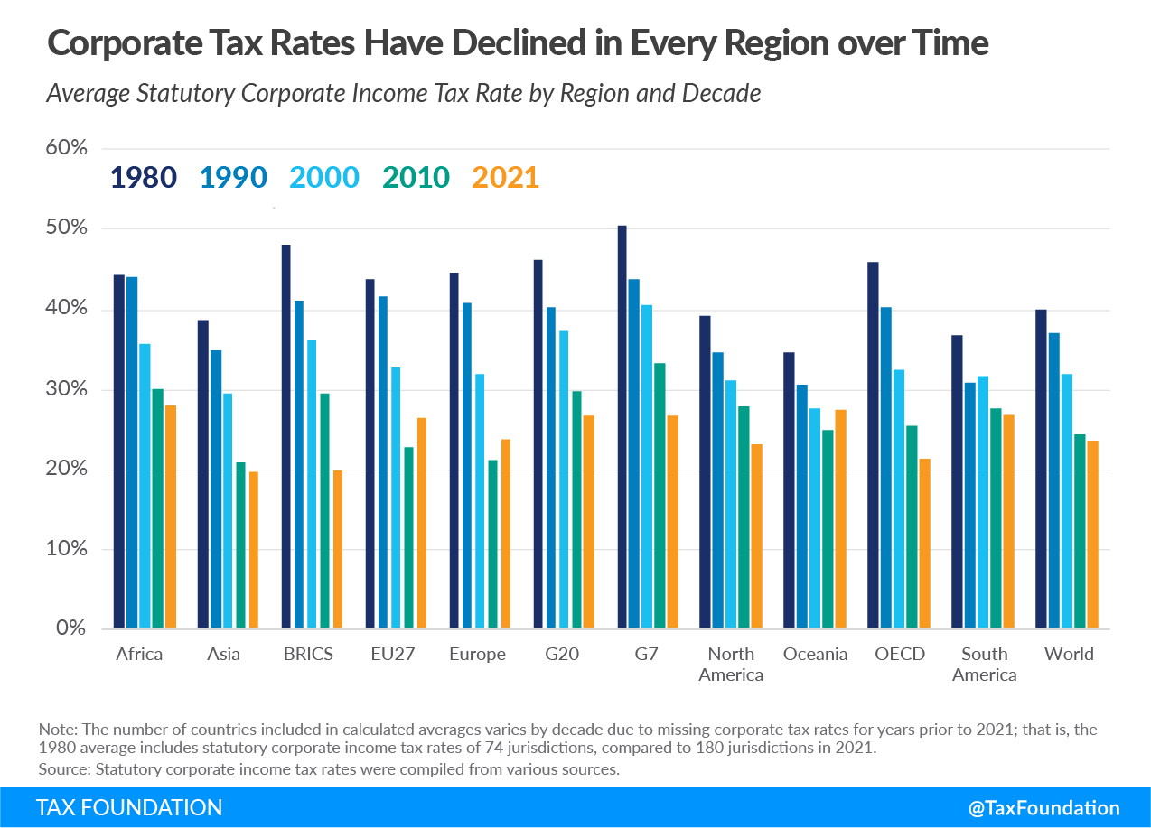
Image Source: https://taxfoundation.org/publications/corporate-tax-rates-around-the-world/

The case for a global minimum tax rate. As discussed in the intro section, taxes pay for public goods. Healthcare, disaster relief, public education, poverty graduation, and social welfare programs are all funded in part by revenue collected via taxes like the personal income tax, value added taxes, taxes on goods and services, and the corporate income tax. In more developed economies, the corporate income tax is a small part of total revenue. That is not the case in most other countries. The corporate income tax makes up 10% of tax revenue in OECD nations, 16% in Latin America and the Caribbean (LAC), 19% in African nations, and 20% in Asia-Pacific nations. The race to the bottom effects mostly poor nations. Poor nations rely most heavily on revenue from multinationals. This is a recipe for declining institutional health, and actively limits the ability of developing nations to address poverty and inequality without foreign intervention.
This trend is played out with the current COVID-19 pandemic, where budgets are strained to their max, and foreign aid is lacking. In an era of learning loss, 2/3rds of low-income countries are cutting back education in favor of health spending. And even with these diverted funds, health spending is woefully small compared to need in most places. Poor nations are drowning in healthcare-related debt in 2021 to address basic needs, while rich nations spend trillions to keep their populace and economy healthy. Crises like the pandemic highlight the inequality between rich and poor nations. While tax revenue is only one of the areas we see this inequality, it’s an important one, and lower revenue here impacts a nations ability to address future crises.
The case against a global minimum tax rate. The important question here is, will multinationals still choose to run their businesses in poor countries once a minimum is introduced? Will these poorer areas of the world lose all benefits from multinationals (jobs, infrastructure, new workforce skills, etc.), when they could have just lost some tax revenue? This is a risk inherent in stopping the race to the bottom. Multinationals, as always, will self-select into the areas that most benefit them. More advanced economies might think that a global minimum tax might benefit them, drawing more business into the national economy now that they are more competitive. While this may be the case for some, new research has come out on the unintended effects on eliminating tax havens that show negative effects on local labor market conditions and corporate domestic investment. Another aspect of a global minimum is enforcement. The global race to the bottom won’t be stopped if there isn’t a unified minimum. If global compliance isn’t achievable, we fall right back into the same trap.
The Two-Pillar Solution to Address Tax Challenges Arising from the Digitalization of the Economy. In October 2021, the Group of 20 endorsed a new global minimum tax of 15% to address the nearly half-century history of decreasing corporate tax rates worldwide and the challenge of modernizing taxes for the increasingly connected digital economy. Supervised by the OECD, the new minimum would be applied to corporations with an annual revenue of more than ~$900 million and is expected to produce an addition $150 billion of tax revenue per year worldwide starting in 2023. The agreement also includes a framework to partially reallocate taxing rights to market jurisdictions (in other words, revenues should follow the customer. Profits in excess of 10% of revenue will be allocated to these areas). This solution aims to counteract profit-shifting, an increasingly problematic trend in the digital economy, where multinationals earn their profits in high tax areas but declare headquarters in low tax areas to avoid payments.
Objections to the agreement. While the agreement includes 137 countries and jurisdictions, it leaves out some important players. Only 25 African countries participated in drafting the Inclusive Framework on Base Erosion and Profit Shifting, leaving nearly half of African nation states out of the accords. Notably, two of the largest economies in Africa – Kenya and Nigeria – participated in the Inclusive Framework, but did not agree with the final recommendations because the new agreements require them to dismantle highly profitable unilateral digital service taxes (DSTs) on companies like Google, Facebook, and Amazon. This objection falls into the category of “there are better, more home-grown solutions closing tax loopholes and shutting down illicit financial flows that fit our unique circumstances.”
Other objections fall into the category of “Who is this really benefiting?”. A 15% minimum tax puts a floor on the race to the bottom, but most countries just aren’t there yet. In fact, only 19 countries/jurisdictions have rates below this new minimum. Nine out of those nineteen are not party to the agreement as of early 2022 (though home countries in this instance would be able to enact an added 15% tax to recoup this loss). The remaining countries are known tax havens, where an increase in the minimum rate will feed revenues back to places like the US and UK. This, combined with the high revenue threshold for multinationals subject to these regulations, set up developed countries as the big winners, and developing countries as taking home the proverbial scraps. The concept of a global minimum tax is still viable here, but not in its current form.
Accolades for the agreement. The agreement tackles profit shifting and base erosion in a meaningful way. While some larger economies stand to benefit, an increase in tax revenue in the amount of $150 billion is good for everyone and reduces tax evasion globally. It is likely to make tech giants pay more in taxes and will spread revenue more evenly to countries where most of the profits multinationals enjoy are earned. The minimum rate will also stop the race to the bottom. While most places are not to or under 15% just yet, the global economy was certainly headed in that direction, and the zero-tax finish line in the race to the bottom has been taken off the table.
In 2022, the international community will be tasked with passing this accord into law. As delegates of General Assembly II (ECOFIN), you will be discussing how, if, or in what form that will happen.

- Guiding Questions

- What is your country’s current corporate tax rate? How might a 15% global minimum impact your country?
- How sensitive are you to changes in corporate taxes? How much of your social services spending is being upheld by revenue from these taxes?
- If there is still an agreement to keep a minimum global corporate tax rate, how would your country implement this policy? How can you guarantee a unified, effective implementation worldwide?
- Is one of your national leaders indicted in the Pandora Papers? Has any action been taken since the release? What should nations do to address these scandals?
- Are you a tax haven? How do you feel about losing a significant chunk of your economy if global minimums are introduced? How do you fit in to the global agenda?
- One of the proposals under the Two Pillar Approach is that some of the tax revenue from multinationals will shift to the jurisdiction with the largest customer base. Think about where your largest multinationals are selling. Does this hurt you or help you?
- Social spending is very important to economic development. Why are developing nations so reliant on revenue that seems kind of fickle. Is there anything to be done to secure important spending (ex. Covering health care costs related to COVID cases).
- What is the best version of a global tax policy for your country? What is the best policy for reducing inequality and proliferating public goods and social welfare? These are not mutually exclusive but are likely to be different.
- Does the world need a global policy? Is it more trouble than it’s worth? Can we make strides in tax evasion and avoidance from a unilateral or regional platform (ex. The African Tax Administration Forum)?

The Pandora Papers are not the first publication of leaked offshore assets. This works follows the Panama Papers closely but is much larger than its 2016 counterpart.
https://www.bbc.com/news/world-58780561
https://www.theguardian.com/news/2021/oct/03/pandora-papers-biggest-ever-leak-of-offshore-data-exposes-financial-secrets-of-rich-and-powerful
https://taxfoundation.org/publications/corporate-tax-rates-around-the-world/
https://en.unesco.org/news/covid-19-two-thirds-poorer-countries-are-cutting-their-education-budgets-time-when-they-can
https://www.jcsuarez.com/Files/Suarez_Serrato_UCETH.pdf
Ironically, this agreement was solidified only days after the Pandora Papers were published by the ICIJ on October 3, 2021.
https://www.nytimes.com/2021/10/11/opinion/tax-havens-global-minimum.html
https://www.undp.org/blog/global-corporate-tax-deal-african-perspective
https://taxfoundation.org/publications/corporate-tax-rates-around-the-world/
https://www.economist.com/finance-and-economics/2021/06/05/will-poorer-countries-benefit-from-international-tax-reform

