Wild Animals and Pandemics – SWFLMUN 2022

Around 5 million people have died of Covid-19 while hundreds of millions of others have been infected. Economies have collapsed. Working people have slipped into poverty. The economic toll of the Covid-19 may reach as high as $28 billion by 2025, estimates Patrick Stewart.
Covid-19 was a huge and damaging pandemic, but it was not unprecedented. It is part of the history of pandemics that are unleashed when viruses or other pathogens are transmitted from animal hosts to humans. Among the preceding pandemics, we might list: HIV/AIDS, Ebola, SARS, Nipah, West Nile, Zika, MERS, H5NI and H1N1 - among others. The question now is not just how to react to pandemics when they emerge through travel restrictions, masking, social distancing and other public health measures, but what can be done to prevent the emergence of future pandemics.

The key measures in this paper have to do with our relationship to the natural world. The more we disrupt natural environments and the creatures that live within them, the more we expose ourselves to dangerous pathogens and viruses. An example of this would be the transmission of HIV/AIDS from primates to human beings as a result of an increased demand for meat that was associated with Belgian colonization of the Congo. Following this crossover from primates to humans, prostitution, conflict, and global travel spread the virus from throughout Africa and then accross the rest world. Covid-19 has similar origins: the outbreak was associated with wet markets for wildlife in Hubei province in China, and in particular, markets in the city of Wuhan. Wuhan was also a major transportation hub, which facilitated the transmission of Covid-19 to other parts of the world. In both HIV/AIDs and the Covid-19, animal to human transmission was a key link in the chain of the causality that generated each pandemic.

The term for animal to human disease transmission is zoonosis or the plural, zoonoses. The key question for this committee is how to control zoonoses as a vector in the transmission of deadly viruses and pathogens. The problems associated with zoonoses are compounded by globalization. Here a set of metaphors might be helpful to consider. We can envision globalization as a set of flows that occur more rapidly and which are more geographically extensive as different regions of the world become more closely connected to one another by means of increased trade, trade, investment and migration. Alongside the officially condoned and licit flows of globalization come other flows which are illicit, but which occur because there is a demand for illicit substances or people or goods which circulate illegally. One of the central issues of globalization is how to manage, contain or suppress these illicit flows.

The CITES Convention

Here is where we can begin to discuss the legal and illegal trade in wildlife. The IPBES, -the Intergovernmental Science-Policy Platform on Biodiversity and Ecosystem Services - published a Workshop Report on the relationship between biodiversity and pandemics in the July of 2020, which notes that the international legal wildlife has increased by 500% since 2005 and by 2000% since the the 1980s. The illegal trade in wildlife - hard to ascertain with precision because it is not reported - was estimated in 2016 to be worth between $7 and $23 billion dollars, nearly 25% of the value of the legal market.

The regulation of the trade of wildlife is subject to the CITES convention - the Convention on International Trade of Endangered Species and Fauna. CITES was established in 1973. It focuses on three different categories of the organisms - Annex l the organisms where are threatened with extinction and not be traded accept for scientific or cultural purposes, Annex ll species that may be traded subject to a scientific determination that such trade would not threaten the species, and Annex lll, a voluntary list of species listed by states who want international cooperation in managing the trade of those organisms. Listing decisions with Annex l and ll are made through a 2/3rds vote of state members of CITES. But states can also opt out of any listing agreement on the basis of overriding economic interests. The agenda for the CITES decisions on which species to list in Annex l or 11 is made through the recommendation of standing committees that monitor trade data pertaining to specific species, but this information does not include data on the illegal trade in wildlife. In this respect, the surveillance capacities of the CITES are limited. One question for delegates to consider in this committee is whether CITES can be adapted to new purposes. Historically, it acted as a safeguard against species extinction. Can it also address reducing the causal linkages between wildlife trade and the spread of dangerous pandemics?

Of relevance here are the efforts of the CITES to regulate the trade in elephant tusks. When elephants were listed as an Annex l species, world ivory prices collapsed and the Ivory shrunk, although not permanently. African states argued for placing elephants on the Annex ll list because the elephant population had rebounded. The CiTES conference of the parties permitted a series of one off sales of ivory so that African states could realize economic benefits from the Ivory trade. In the meantime, though, illegal poaching soared, driven by high market prices for Ivory on the one hand and widespread poverty in Southern and Eastern Africa on the other. This underscores the problem of controlling illicit flows of organisms when there is a high demand for them.

In China, for example, the increasingly wealthy middle class is the main consumer of traditional Chinese medicine (referred to as TCM). The United States and the EU are leaning consumers of legally traded wildlife for pets. Shipments rose from 7,000 to 13,000 per month between from 200 to 2015, which, as the IPBES Workshop Report notes, led to the introduction of new diseases in the U.S. - Monkeypox and the tick vector. In China, on the other hand, TCM is poised for renewed growth in the wake of the pandemic. Much of TCM does not consist of the wild animal trade but some does: for example, the Chinese cobra - associated with the dissemination of the Covid-19, pangolins, and endangered tigers the rhinos.

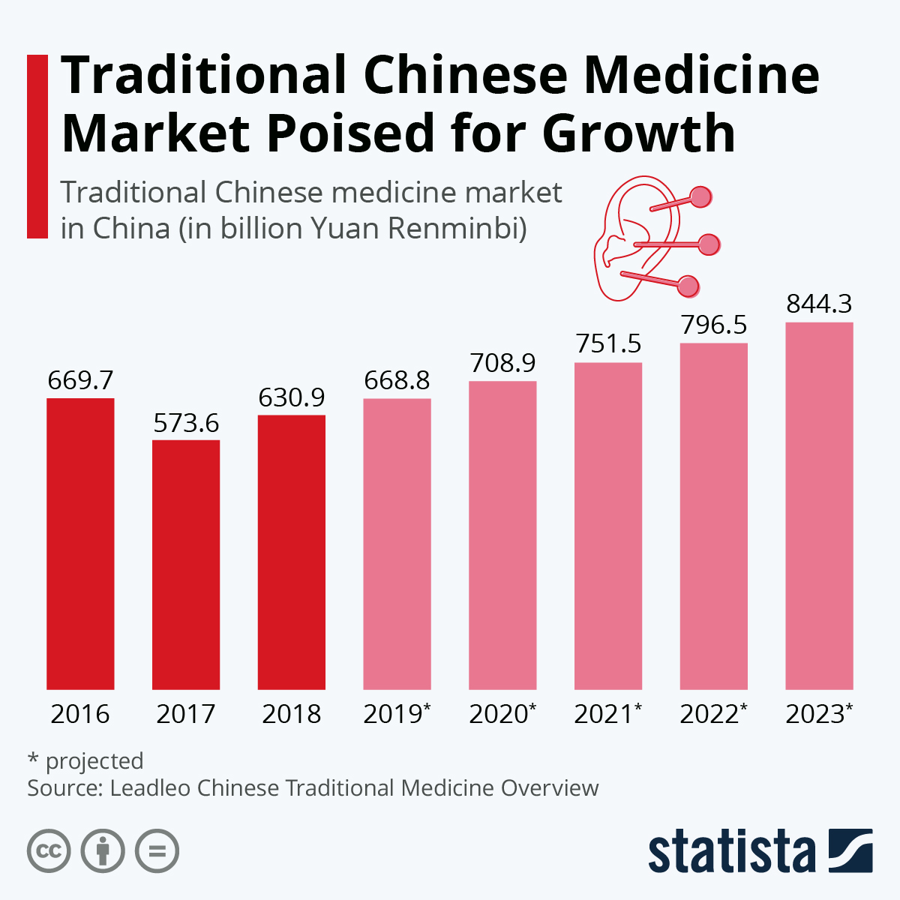
Source: Statistica

The Pandemic-Wildlife Linkage

The transnational mobility of wildlife multiples the dangers of the zoonoses. The IPBES reports, in this regard, on the results of a 10 year study of traded pangolins (see photo below) Seized in their country of origin, the pangolins in this study “revealed a complete lack of zoonotic viruses” but “two different groups seized at the end of their trade route were found to contain coronaviruses with genetic element closely related to SARS and COV-2.” Several factors explain these outcomes. Among them, the proximity of the pangolins to other animals in transit, opening of pathways for virus transmission that did not exist in the original environments of any of these creatures. An additional reason for virus transmission was the stressed condition of the animals due to their capture and transhipment.

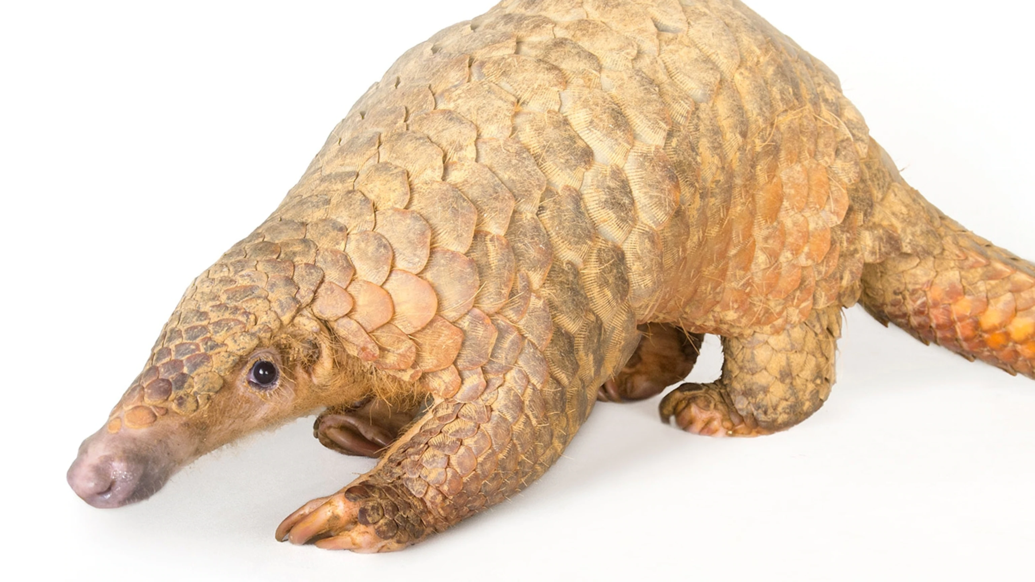
The Pangolin - National Geographic - Pangolin scales are an important ingredient in Chinese Traditional Medicine.

These findings suggest the need for greater regulation of wildlife trade, but as IPBES (see section 3 of this report) points out, “the legal and regulatory framework for wildlife trade is often unclear” because most regulators are concerned with the management of natural resources and lack health expertise, “making it difficult to organize appropriate health surveillance and risk assessment protocols.” The need for this type of oversight increases as human populations surge into remote natural regions and create new interfaces between themselves and the various pathogens that have evolved in these areas. These sorts of dangerous connections are generated by extensive processes of development. From this point of view, one might raise questions about China’s Belt and Road initiative, which is building new infrastructure to connect China markets and sources of raw materials across Central Asia, East Africa, the Middle East, and Europe. Unless they are appropriately monitored, these new networks of trade and investment can be perilous.

Here we might reconsider the significance of the CITES convention. An editorial in Scientific American explains that the linkage between wildlife trade and infectious disease (Covid-19) focused international attention on the prevention of zoonotic diseases and epidemics. There are numerous international organizations that could play a role - the World Health Organization, the World Organization for Animal Health, the World Trade Organization and the Convention of Biodiversity - “but none of these have experience in dealing with the transport terrestrial wlfd animals,” which is the forte of CITES. Moreover, with a membership of 183 states, CITES has a mandate to regulate international wildlife trade. The CITES treaty could be revised in order to address the risks of zoonotic disease transmission. But opening the treaty up to renegotiation, speculates Scientific American, risks consideration of amendments and protocols that could weaken the CITES convention. Better to proceed by means of adding an addendum of the existing convention which would operate by means of the reverse listing. The assumption here would be similar to the precautionary principle, which argues that protective action should take place before complete scientific proof of risk has been established. The reverse lising would be that “all wild animal species are presumed to be high risk until it is determined that they are safe to trade.”

This is not a complete solution. One of the difficulties would be securing the agreement of state parties to the proposed ban of all animal species presumed to be of high risk. Under the CITES convention, two thirds of the states must agree to list organisms on either Annex l or ll. The proposed addendum would shift authority from states to experts. The other difficulty about bans - all too familiar for anyone acquainted with the “war on drugs” is that bans do not eliminate the market demands for wildlife species; they tend, instead, as a Brookings Institute Report notes, to push the market underground “without any enforcement and pathogen monitoring....the policy outcome can be worse than the original problem.”

It is noteworthy that the pandemic has actually exacerbated the conditions that helped to create it by means of shutting down international travel and tourism. This has starved the African countries of ecotourism revenues that sustain local communities, rangers, landowners and protected area administration. As these structures have weakened, poaching has been on the rise, driven by diminished enforcement capacity in African states - a result of the ecotourism downturn - but also larger systemic factors such as growing populations in Africa and increased pressures on ntive habitats. As the Brookings Institute notes, “Budget starved governments are susceptible to entreaties by powerful extractive industries promising rapid revenues from loggin, mining and agricultural production. Unemployed people have been desperately seeking jobs in illegal logging, mining and poaching, especially as Covid-19 has produced reverse migration from urban spaces to rural ones for the first time in decades.”

Possible Solutions

The Brookings Report makes several recommendations that delegates may want to consider as they tackle this issue. In general, the report advocates smart regulations rather than outright bans. That said, unhygienic markets in wild animal meat and live animals should be phased out with traders compensated for losses, but not all wet markets should be banned in China or other countries because they provide people with access to food. In general bans on wild meat consumption run the risk of undermining the food security of the economically insecure people, particularly in Africa. Rather than banned, wild meat consumption can be phased out while alternative sources of both protein consumption and income generation are developed. Another important driver of the trade in animals is Traditional Chinese Medicine (TCM). The TCM lobby is politically powerful in China and the claims of TCM medicine are controversial. For example, the government of China promoted - without proof - the use of TCM as a cure of Covid-19 in order to expand exports of TCM products. In the United States and the EU, the importation of the exoctic animals as pets should likewise be curtailed.

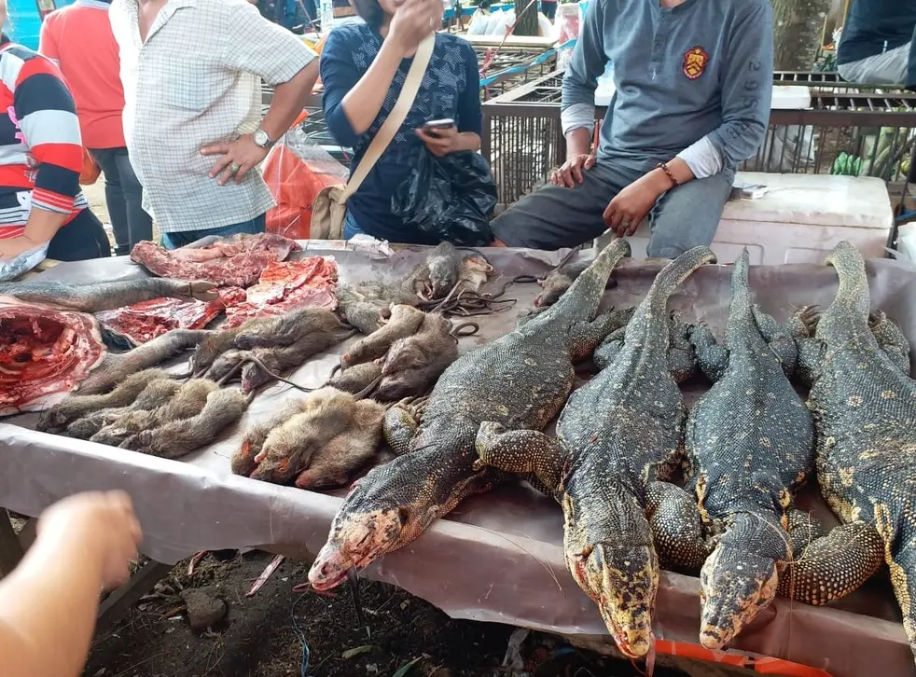
Source: this image is from the UK newspaper, Independent, from May 19, 2020. The accompanying headline reads: Coronavirus: live animal markets and wildlife trade continue in Asia amidst calls for the crackdown.

These politics might be understood as part of a comprehensive effort to modify a set of dangerous interfaces between human beings and the natural world. These policies would also have to be complemented by stronger efforts to stem deforestation. There was recent action on this front at the COP 26 meeting on climate change in Glasgow, Scotland. On November 10, the New York Times reported that “Leaders of more than 100 countries, including Brazil, China, Russia and the United States, vowed at climate talks in Glasgow to end deforestation by 2030, in a landmark agreement that encompasses some 85 percent of the world’s forests.” Environmental activists criticized the agreement, saying that it lacks enforcement action and allows for deforestation to continue throughout the 2020s. Supporters of the agreement respond that the agreement does promise funding to curtail deforestation, including significant funding ($1.7 billion) for indigenous peoples to act as stewards of these environments. The larger point here is the leverage that action of deforestation provides to a range of crucial environmental and public health objectives - climate change, biodiversity conservation and eliminating the sources of pandemic diseases. Delegates may consider addressing deforestation in their discussion of the relationship between wild animals and pandemics.

Guiding Questions:

- To what extent and in what ways can the CITES Convention be used to address the spread of zoonotic diseases?
- Can reverse listing of the animal species serve as a way of curtailing the zoonotic spread of disease?
- What approaches and resources can be used to address the illegal transfer of organisms that way become vectors of infectious disease?
- What types of commitments can be made to strengthen the regulatory capacities of the governments to monitor the trade in wildlife species?
- Can a strategy of legalization combined with heightened regulation and increased suppression of illicit trade in wild animals succeed in reducing the risk of zoonotic disease?
- How can the trade in wildlife meat be subject to greater regulation without undermining the food security of the people who depend on this trade?
- How can efforts to stem the spread of zoonotic disease be linked to policies that ends deforestation?

Suggested Readings

- Vanda Felbab-Brown, “Preventing Pandemics through biodiversity conservation and small wildlife trade regulation,” Brookings Institute, January 25, 2021.
- Bruce Weissgold, Peter Knights, Susan Lieberman, Russell Mittermeier, How We Can Use the CITES Wildlife Trade Agreement to Help Prevent Pandemics, Scientific American, August 20, 2020.
- Patrick Stewart, “To Prevent Future Pandemics, Start by Protecting Nature,” World Politics Review, May 10, 2021, 1-4.
- IPBES Workshop on Biodiversity and Pandemics, 2000
- CITES Convention Homepage

See Patrick Stewart, “To Prevent Future Pandemics, Start by Protecting Nature,” World Politics Review, May 10, 2021, 1-4.
Information about the CITES convention is drawn from Pamela Chasek, David L. Downie and Janet Welsh Brown, Global Environmental Politics, Sixth Edition, Westview Press, p.196-207/

