Geopolitics of the Melting Arctic
By Madison Alberts

Arctic Geopolitics
With rising temperatures all across the world, and most devastatingly, in the Arctic, the Trump administration found an economic opportunity within the newly melted waters of the North. This new open area within the Arctic Sea, due to the melting of glaciers and ice caps, has the chance of wielding extremely valuable and precious resources. Uranium, natural gas, oil, zinc, and other resources are just some of the various examples that can be found. The threat of economic exploitation and commercialization of the sea is now underway, and many countries have already tried making strategic advances.
For example, Trump has recently offered to buy Greenland, a semi-autonomous region controlled by Denmark. The move was an effort to expand the US’ geopolitical advantage. Michael Klare explains the move:
“Under existing international law, codified in the U.N. Convention on the Law of the Sea (UNCLOS), coastal nations possess the right to exploit undersea resources up to 200 nautical miles from their shoreline (and beyond if their continental shelf extends farther than that). The Arctic Five have all laid claim to “exclusive economic zones” (EEZs) in those waters or, in the case of the United States (which has not ratified UNCLOS), announced its intention to do so. Most known oil and gas reserves are found within those EEZs, although some are thought to be in overlapping or even contested areas beyond that 200-mile limit, including the polar region itself. Whoever owns Greenland, of course, possesses the right to develop its EEZ,”.
The applied geopolitical strategy explained simply would entail the expansion of the United States’ resources and availability in the region, thus allowing for increased extraction and in turn, profits. In addition, the Administration won’t explicitly say that climate change is the source of this newfound revenue, but instead, they will use national security and national interests as a front.
Russia and China have, too, made some premeditated calculations and tactical plans within the region. In particular, Russia has the most to gain or lose with the melting of the ice. In a report conducted by the Center for Strategic and International Studies, there are three main goals that Russia hopes to cash in on: “to boost defense along its northern border, especially as interest in the Arctic begins to rise due to ice melt and potential new passageways; to protect its economic future; and, to establish a stage upon which it can project power,”. This doesn’t come without consequence, though. Russia’s permafrost on its mainland is now melting and is wreaking havoc over many of its oil production sites. Just recently, the biggest oil spill in Russian history occurred with an estimated environmental recovery time at ten years.
On the other hand, China is using the ice melt to its advantage as well. It has recently become one out of seventeen observer states on the Arctic Council, in which it sits with member states Canada, Denmark, the United States, Finland, Iceland, Norway, and Russia to monitor the Arctic. This new position has led China to develop a white paper expressing an interest in a “Polar Silk Road.” The new pathway would drastically cut-down travel time from Asia to Europe and help bolster the already mega-giant Chinese economy. The Chinese also desire to have some kind of influence in the governance of the Arctic, which has raised some suspicion on the behalf of Russia; whom of which has the most at stake in the Arctic. While Russia’s suspicion of Chinese whereabouts in the region lingers in the background, their relationship also comes with some mutually beneficial and favorable perks. If they are to maintain and balance a stable relationship without one nation overpowering the other, the possibilities for the two are great. Huge financial gains as well as classical geopolitical applications would strengthen their increasingly friendly correspondence. The question remains as to whether China and Russia will continue to work together or not; however, their budding relationship could be a game-changer if they manage to keep their goals aligned.
The United States’ response to the complex Sino-Russian relationship has ramped up the militarization of its share of the Arctic as well. In fact, “for the first time since the end of the Cold War, the U.S. Navy is making regular trips to the Arctic Circle,”. Their reactivation into the area, and specifically the Barents Sea, is a defensive and preemptive move. US Military leadership is well aware that stationed within the Barents Sea are Russian nuclear submarines, which have operated relatively freely over the last several years. Moreover, the move was supposed to be a message to Russian military officials from the US that they can no longer run about how ever they please. In other words, there is a new sheriff in town, and Russia is not happy about it.

Law of Sea
The Law of the Sea (LOSC) is an international binding agreement between the US, Canada, Russia, Denmark, and Norway declaring particular rules and regulations within the Arctic and other oceans. Some of these rules include the “12 nautical mile Territorial Sea, 24 nautical mile Contiguous Zone, and 200 nautical mile Exclusive Economic Zone (EEZ)”. Anything past the solid red line on the map below is up for grabs to whomever can prove their claims with scientific evidence demonstrating whether a continental shelf associated with the territory of a given country extends further into the ocean. So far, Norway and Iceland are the only countries to have both their claims approved by the UN special committee, the International Maritime Organization and its special Marine Environmental Protection Committee (IMO and MEPC, discussed in detail further down). Interestingly, there are no diplomats on this committee; there are only scientists who use bathymetry and geology to uphold their decisions.
Perhaps their biggest responsibility right now is the use of science to correctly and objectively mark out the territory of the ocean that’s being contested. They mainly use the information gathered past the continental shelves of each respective country in order to determine who is entitled to what as the ice melts. This process basically sets in stone who can go into which waters, who can collect which resources, and who can defend which zones. The problem is many points past the continental shelves and EEZs do not perfectly line up to the way political maps are drawn, so many spots overlap between two or more countries “designated” spots. For example, Norway and Russia were in a dispute over rights to fishing grounds and hydrocarbon exploration within the Barents Sea, but since the Barents Sea Treaty of 2011, the two have worked aside their differences, realizing that they could both help each other ensure resource stability within an increasingly competitive market.
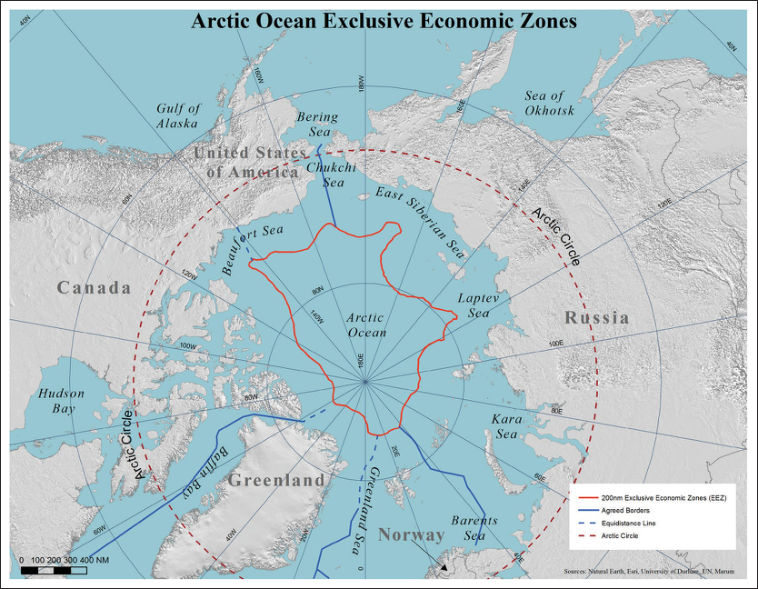
Figure 1: Shows the Exclusive Economic Zones (EEZ) for each country within the LOSC convention agreements. Take note of the disputed and undisputed borders marked by the different styled line, defined in the key on the right-hand, bottom corner (https://sites.tufts.edu/lawofthesea/chapter-eight/) .
Figure 2: Shows the distribution of known resources within the Arctic Sea. Take notice of where the resources are located on the map and relate their location back to their corresponding production countries. “Resources in the Arctic 2019 | Nordregio.” 2019. Nordregio. January 16, 2019. https://nordregio.org/maps/resources-in-the-arctic-2019/.
Another aspect of international disputes in the Arctic are about maritime trade passageways and overlapping seabeds. The trade disputes are mainly between Russia and Canada where they both claim that trade routes that go through their territory have to get permission from their respective governments before continuing their voyage. The US claims, otherwise, saying that the trade routes are international waters and that no one country has the claims to them. As previously discussed, the other dispute regarding the overlapping seabeds involved Russia and Denmark. Extending the claims to deep-sea seabeds would increase the availability of resources to the countries within the jurisdiction of the LOSC. Retired Admiral James Stavridis from the U.S. Navy (Ret.) says that “extended continental shelf claims are disputed in many regions of the world, but the Arctic has the most natural resources under contention by volume”. As of today, the Committee on the Limits of the Continental Shelf (CLCS) has not made any resolutions towards these problems but instead uses geological and bathymetric findings in order to provide an “independent assessment” for bilateral agreements between the member states (Stavridis 2021).

The International Maritime Organization and Polar Code
The International Maritime Organization (IMO) is a specialized agency and entity of the United Nations (UN) that is responsible for the “safety, security, and environmental performance for international shipping”. In short, it enforces international shipping rules so that companies don’t take advantage of the environment or their employees to benefit financially, similar to a worker’s union. It was created in hopes of catalyzing a more competitive, innovative, and efficient market at the international level. In fact, more than 80% of global trade relies on international shipping, so the IMO has a tremendous responsibility towards upholding its mandate.
Moreover, the IMO is working with Sustainable Development Goals (SDGs) at the UN and concentrating their efforts into the 2030 Agenda. Some key areas of this agenda that the two groups are working on are “SDG 14 (life below water), SDG13 (climate change), SDG9 (industry, innovation and infrastructure) and SDG5 (gender equality), next to the over-arching SDG17 (partnerships and resource mobilization)”. Focusing on SDGs 13, 14, and 17, the IMO plans on using its MEPC branch to oversee and advance towards its upcoming goals. As of now, they have a draft of a new policy that should be approved later this year. Within this draft it mandates: a 40% reduction of emissions from shipping by 2030, the use of a worldwide, enforceable grading system that rates the eco-friendliness of shipping units, and provides extra support to current carbon reduction policies such as the “Annex VI of the 1973 International Convention for the Prevention of Pollution from Ships”. With the continued progress of the shipping industry, they should reach and surpass these goals; however, an examination of the progress and effectiveness of the new draft will be tested in 2026.

The Arctic Council
The Arctic Council is a non-binding intergovernmental organization established in 1996 that “promotes cooperation, coordination and interaction among the Arctic States, Arctic Indigenous peoples and other Arctic inhabitants on common Arctic issues”. Before the Arctic Council, its predecessor was the Arctic Environmental Protection Strategy (AEPS), which shockingly enough, was created by Mikhail Gorbachev with his 1987 Murmansk speech. This speech essentially started the movement for a peaceful and inclusive organizational framework towards preserving the Arctic Sea. Today, instead of the AEPS, members of the Arctic Council, (Canada, Russia, the United States, Norway, Finland, Iceland, Sweden, and Norway), continue to uphold this order of peace in their pursuit towards an Arctic that benefits all, even with mounting international pressures.
Earlier, the main players within the Arctic Circle were mentioned; however, there are other key actors, many of whom are part of the European Union and Arctic Council alike such as Norway and Denmark. These two countries continue to play an active and integral part of protection and innovation within the region. A great example would be the teamwork between Norway and Russia’s resurrection of the fishing industry in the Barents Sea after a historically low supply of cod from illegal fishing activities. Resulting from their cooperation, they have nearly eliminated illegal fishing completely in the region. As for Denmark, they contribute heavily towards scientific research and development in the Nordic Council and International Arctic Science Committee, but it does have disputes of its own over contested territories; specifically with Canada over Hans Island. Although this conflict has the potential of dictating the power dynamics in the Arctic, it is not premeditating future violent outbreaks. If anything, it and the previous examples discussed above exemplify the multilateral efforts from many countries to peacefully and methodically safeguard the future of the Arctic with a rules-based order in mind.
Not all the voices within the Arctic Council are countries though. There are branches of native consultants in the Arctic Council that help shape the development and conversation over new Arctic Circle policies. These consultants are a part of the Council’s Permanent Participants (PPs). Some of the things they do, for example, are notice natural patterns that corroborate the findings of scientists such as increasing erosion along coastal shorelines, the development of extreme weather and storms, and the increase in wave size in the ocean. In fact, their observations are taken extraordinarily seriously within the Arctic Council, for much of their knowledge precedes most recorded scientific findings before the 20th century. Moreover, there are six Permanent Participants in the Arctic Council who represent the various indigenous peoples living in the Arctic Circle. They are the Aleut International Association (AIA), Arctic Athabaskan Council (AAC), Gwich'in Council International (GCI), Inuit Circumpolar Council (ICC), Russian Association of Indigenous Peoples of the North (RAPION), and the Saami Council.
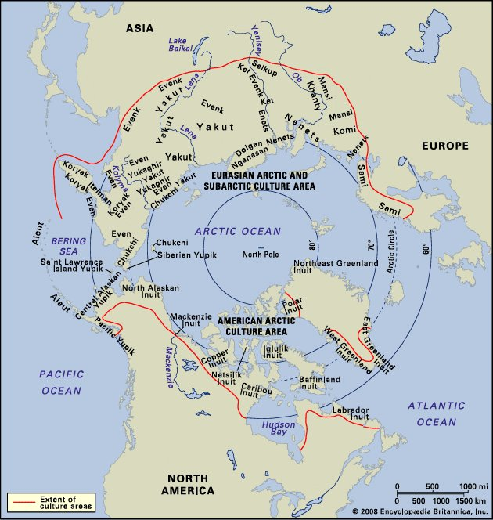
Figure 3: Shows the distribution of different native populations within the Arctic Circle. Notice how the majority of these groups are in Canada, the US (Alaska), and Russia. “Native American - the Arctic | Britannica.” 2021. In Encyclopædia Britannica. https://www.britannica.com/topic/Native-American/The-Arctic.

Conclusion
Even though the future of the Arctic is unknown now, there are a number of important conclusions to draw moving forward. First, the intensity and scale of the melting Arctic depends on everyone doing their part. In order to achieve the goals set out by countless governmental and nongovernmental organizations, there must be a cohesive and united effort for change. Now, the US is one of the countries out to undo its previous environmental mistakes. In fact, President Joe Biden’s first executive order upon his arrival in office was to rejoin the 2015 Paris Accords. Next, there is not an old western, California Gold Rush style race to the Arctic. This is imperative to keep in mind, for there are countless organizations in place that instill rules in the region: the IMO, the UNLOSC, and the AC. There is, however, a systematic way for new, outside players to lay claim to the so-called “donut hole” in the Arctic Ocean that is open international waters. Lastly, the ramping up of security in the region is strange in some ways, but it does give some insight. These militaristic measures follow trends of classical power politics as a new region moves from the background to the foreground with increasing importance. It is doubtful that a full-scale, violent conflict will arise with the continued and extensive use of diplomacy, but discretion by all parties involved is being taken. If the world is to come out unscathed from the possible climate change catastrophe that looms overhead, the persistent use of diplomacy and environmental protection must be placed first before the economic gains.
Guiding Questions
- The consistent use of diplomacy to handle almost all disputes in the Arctic between countries has been a shining example of international cooperation. Do you think that this type of regional governance will become more common in the future, why or why not? Think of the effects of NAFTA, the EU, and other regional organizations.
- How will the increased military operations from various actors in the Arctic affect the future of NATO, the Collective Security Treaty Organization (CSTO)? What about the Sino-Russian-American relationship?
- How could the Arctic’s resources stimulate the international and regional economies of the region? Think back to the time cut for shipping and trade routes between Eurasia and the various passageways. Is economic growth worth or not worth the potential environmental costs that may come with this success?
- Remember the different SDGs the IMO set out. What more can other organizations and countries be doing to achieve similar goals set out by the Paris Agreement of 2015? Should there be incentives for environmentally friendly change by companies and governments? What about disciplinary actions for those who fail to help out?
- The effects that come with climate change can change the way trade is conducted, but it will also change the world’s entire way of life as we know it. What are some of the ways the melted ice can affect those who live in the Arctic and the rest of the world? How might the international community be able to prevent, protect, or mitigate these changes?
- What can be done to ensure that the interests of non-Arctic states are addressed as the Arctic melts and becomes more accessible for commerce and resource development?
- From the point of view and within the interests of non-arctic states would be the status of trade routes – in particular, the Northwest Passage and the Northern Sea Route? Are these areas subject to the exclusive jurisdictions of Canada and Russia?

Further Recommended Readings
- European Environment Agency Report: https://www.eea.europa.eu/soer/2015/countries/arctic
- “The Changing Shape of Arctic Security”: https://www.nato.int/docu/review/articles/2019/06/28/the-changing-shape-of-arctic-security/index.html
- “China Launches the Polar Silk Road”: https://www.csis.org/analysis/china-launches-polar-silk-road
- “The Emerging Arctic”: https://www.cfr.org/emerging-arctic/#!/
- “China, Russia, and Arctic Geopolitics”: https://thediplomat.com/2020/03/china-russia-and-arctic-geopolitics/

‌

Klare, Michael. 2019. “The Pompeo Doctrine.” TomDispatch.com. September 12, 2019. https://tomdispatch.com/michael-klare-a-formula-for-catastrophe-in-the-arctic/.
Femia, Francesco. 2020. “Emerging Threat: As the Arctic Melts, Russian Plans to Militarize Could Create a Nuclear Hotspot.” The Center for Climate & Security. August 26, 2020. https://climateandsecurity.org/2020/08/emerging-threat-as-the-arctic-melts-russian-plans-to-militarize-could-create-a-nuclear-hotspot/.
Bedingfield, Will. 2019. “As the Arctic Melts, China and Russia Struggle for Control.” WIRED UK. WIRED UK. December 11, 2019. https://www.wired.co.uk/article/arctic-ice-melting-shipping-russia-china.
“China, Russia, and Arctic Geopolitics.” 2020. Thediplomat.com. March 29, 2020. https://thediplomat.com/2020/03/china-russia-and-arctic-geopolitics/.
Larter, David B. 2020. “The US Navy Returns to an Increasingly Militarized Arctic.” Defense News. Defense News. May 12, 2020. https://www.defensenews.com/naval/2020/05/11/the-us-navy-returns-to-an-increasingly-militarized-arctic/.
US Department of Commerce, National Oceanic and Atmospheric Administration. 2013. “What Is the Law of the Sea?” Noaa.gov. 2013. https://oceanservice.noaa.gov/facts/lawofsea.html.
Witte, Niklas. 2013. “The Barents Sea Conflict: Russia and Norway Competing over Fossil Fuel Riches in the Arctic.” Inquiries Journal 5 (09). http://www.inquiriesjournal.com/articles/758/3/the-barents-sea-conflict-russia-and-norway-competing-over-fossil-fuel-riches-in-the-arctic. ‌
“Chapter 8: The Arctic & the LOSC – Law of the Sea.” 2021. Tufts.edu. 2021. https://sites.tufts.edu/lawofthesea/chapter-eight/.
“Introduction to IMO.” 2019. Imo.org. 2019. https://www.imo.org/en/About/Pages/Default.aspx#:~:text=IMO%20%E2%80%93%20the%20International%20Maritime%20Organization,and%20atmospheric%20pollution%20by%20ships..
“UN SYSTEM SDG IMPLEMENTATION.” 2021. Un.org. 2021. https://sustainabledevelopment.un.org/content/unsurvey/organization.html?org=IMO.
IISD's SDG Knowledge Hub. 2020. “IMO Advances Measures to Reduce Emissions from International Shipping | News | SDG Knowledge Hub | IISD.” Iisd.org. 2020. https://sdg.iisd.org/news/imo-advances-measures-to-reduce-emissions-from-international-shipping/.
“Permanent Participants.” 2017. Arctic Council. 2017. https://arctic-council.org/en/about/permanent-participants/.
Mayer, Elizabeth. n.d. “ESTABLISHING the ROLE of PERMANENT PARTICIPANTS on the ARCTIC COUNCIL How Arctic Indigenous Groups Gained Recognition on the Arctic Council.” https://jsis.washington.edu/wordpress/wp-content/uploads/2019/01/Elizabeth_Mayer_attachment.pdf.
Archives. 2019. “Managing the Arctic: A Norwegian Perspective.” Harvard International Review. Harvard International Review. August 23, 2019. https://hir.harvard.edu/managing-the-arctic-a-norwegian-perspective/.
Borgerson, S., Brigham, L., Byers, M., Conley, H. and Laruelle, M., 2014. The Emerging Arctic. [online] Cfr.org. Available at: https://www.cfr.org/emerging-arctic/#!/#overview.
“Indigenous People: Impacts | National Snow and Ice Data Center.” 2019. Nsidc.org. 2019. https://nsidc.org/cryosphere/seaice/environment/indigenous_impacts.html.
“Permanent Participants.” 2017. Arctic Council. 2017. https://arctic-council.org/en/about/permanent-participants/.
University, Stanford. 2021. “Research and Policy in a Changing Arctic | Stanford News.” Stanford News. Stanford University. March 23, 2021. https://news.stanford.edu/2021/03/23/research-policy-changing-arctic/.
Lanteigne, Marc. 2019. “The Changing Shape of Arctic Security.” NATO Review. June 28, 2019. https://www.nato.int/docu/review/articles/2019/06/28/the-changing-shape-of-arctic-security/index.html.

